Southern NH Services, Inc.-Child Development Program

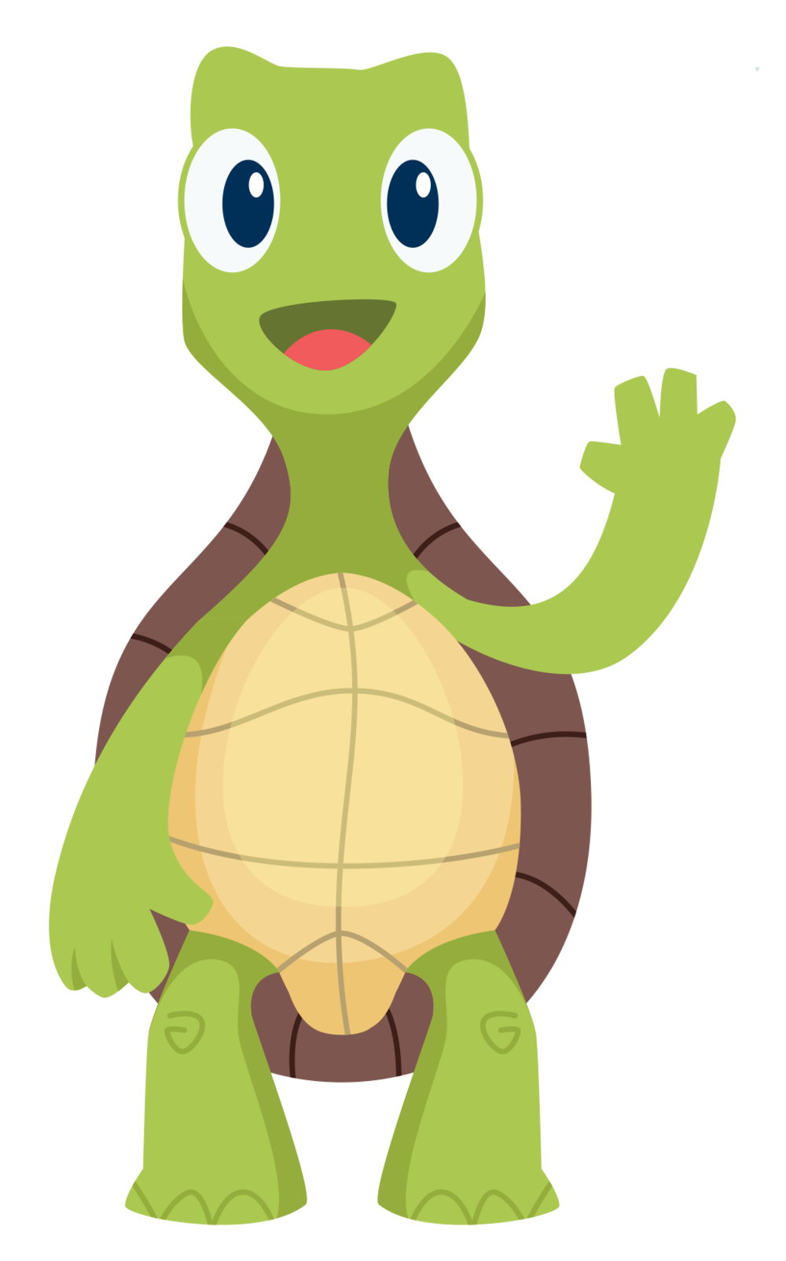

**Social Skills Lessons**

**based on Pyramid Model Strategies**



Updated 2023

Contents

Summary ________________________________________________________________3

Planning ______________________________________________________________4-5

Notes for Interns _____________________________________________________________6

Planning Form ______________________________________________________________7

Lesson 1 _______________________________________________________________8-9

Lesson 2 _______________________________________________________________10-11

Lesson 3 ________________________________________________________________12-13

Lesson 4 ________________________________________________________________14-15

Lesson 5 _______________________________________________________________16-17

Lesson 6 _______________________________________________________________18-19

Lesson 7 ____________________________________________________________20-21

Appendix

Animal Cards _________________________________________________23-25

Tucker Turtle Pieces ______________________________________________26

Sharing Cue Cards _____________________________________________27-28

Super Friend Coloring Page ________________________________________29

Flyer __________________________________________________________30

Lesson Handouts ______________________________________________31-37

Certificate ______________________________________________________38

**Summary**

**Goals of the lessons**

Introduce the following concepts and plan to incorporate strategies into the classroom environment, routine, and practices.

1. **Emotional Literacy for self and others**
2. **Manage frustration/anger**
3. **Gain peer play skills**

**Lesson 1**-Establish Rules/Know your feelings:

**Lesson 2**-Dealing with Feeling Mad/Tucker the Turtle

**Lesson 3**-Dealing with mistakes

**Lesson 4**-Problem Solving

**Lesson 5**-Sharing

**Lesson 6**-Playing with others

**Lesson 7**-Give a Compliment/Gratitude

These lessons are built on the foundation of the Pyramid Model. Resources provided were developed by National Center for Pyramid Model Innovations at challengingbehavior.org. The intention is for this to be an additional dose of these materials and concepts. They should be incorporated into the overall classroom environment to support proficiency of the skills. Children with strong social emotional skills show improved academic success and develop healthy friendships. Information is sent home each lesson for families to also support the child’s skills at home.

Teachers can be incorporate lessons into the classroom to meet the needs of the children. Lessons can be supported a specialist, family worker, supervisor, or intern. The classroom should be broken down into smaller groups, 6-9 children, to support more direct instruction/attention from the facilitators. Lessons should run about 20 minutes. Agenda can be modified to meet the needs of the group or individual goals. Each week is intended to build on the previous week’s goals. Portions of agenda are repeated to build skill and should be incorporated in the classroom and supported at home.

Originally these lessons were designed to provide for a social skills group with 4-7 children with 2 facilitators. We have found that without providing opportunities for children to practice the skills and build into the classroom culture, there was little impact. Planning for intentional integration into the environment, routines, and classroom practices is key to meaningful outcomes for children. Some children may need additional teacher support to develop the intended skills.

I want to thank the many interns that have utilized this curriculum and have provided feedback to strengthen the agenda. Your time and dedication to our program are much appreciated.

~Dawn

**Planning**

Teachers

* Collect all needed materials
* Prepare for each lesson
  + Become familiar with goal, materials and activities needed for each lesson
  + Plan adjustments (Books may be substituted based on availability or preference. Any adjustments should meet the main goal for the lesson.)
  + Read book prior to lesson to be familiar
* Designate tasks and roles for each lesson including prep
* Reach out to SE Team for support with materials

Children

* Consider the strengths and goals for each individual child
  + Based on screening results, observations, family input
* Plan to split classroom into small groups (6-9 children)
* How will you support individual needs and the needs of the group?
* Consider grouping to allow for each child to be successful, balance shy and outgoing students

Location/Schedule

* Decide when and where the lessons will occur
* Consider needs of the space (distractions, materials available, rules of space, strategies to define space)
* Plan how the lessons will fit into the overall schedule including transitioning children from previous activity and into the next

Families

* Provide flyer to families with accurate information (facilitators, time, location)*
* Flyer and lesson handouts are found at <https://snhschilddevelopment.weebly.com/social-skill-lessons.html>
* Provide handout following each lesson for families
* Offer materials to support skills at home as families are interested

Documentation

* Make ChildPlus entry as an Education: Social Emotional Note that child attended or missed lesson

Materials needed for lessons:

Each lesson will provide list of materials needed for this lesson. Most visuals will be utilized each lesson. Links to find printable materials are listed in each lesson. Any poster can be sent home with children to extend the lesson. Books may also be shared with families. Materials may be altered to reflect the classroom tools.

|  |
| --- |
| Flyer describing lessons and when they will take place |
| Handouts to be provided after each lesson describing activities and how to support at home |

|  |  |  |  |
| --- | --- | --- | --- |
| **Lesson** | **Posters** | **Books** | **Activity** |
| 1 | [Classroom Rules](https://snhschilddevelopment.weebly.com/uploads/1/3/1/2/13125961/bee_rules-1_page.pdf) | [*Feelings*](https://challengingbehavior.org/docs/TuckerTurtle_Story_Home_SP.pdf) | Animal cards  [Feeling cards](https://challengingbehavior.cbcs.usf.edu/docs/FeelingFaces_cards_large_EN-SP.pdf) |
|  | [Feelings](https://challengingbehavior.cbcs.usf.edu/docs/FeelingFaces_chart_EN-SP.pdf) |  |  |
|  | [Feelings Thermometer](https://challengingbehavior.cbcs.usf.edu/docs/Relaxation-Thermometer.pdf) |  |  |
| 2 | [Tucker Turtle Steps](https://challengingbehavior.org/docs/TurtleTechnique_steps.pdf) | [*Tucker Turtle Takes Time to Tuck and Think*](https://snhschilddevelopment.weebly.com/uploads/1/3/1/2/13125961/new_tuckerturtle_story.pdf) | Tucker pieces, plates, art materials |
| 3 |  | [*Minnie Makes a Mistake*](https://snhschilddevelopment.weebly.com/uploads/1/3/1/2/13125961/minnie_made_a_mistake.pdf) | Bucket and balls or beanbags |
| 4 | [Problem Solving Steps](https://snhschilddevelopment.weebly.com/uploads/1/3/1/2/13125961/solutions_page-new.pdf) | [*We Can Be Problem Solvers!*](https://snhschilddevelopment.weebly.com/uploads/1/3/1/2/13125961/problemsolving_story.pdf)  *(*with cue cards on page 14-16) |  |
|  | [Solutions](https://snhschilddevelopment.weebly.com/uploads/1/3/1/2/13125961/solutions_page-new.pdf) |  |  |
| 5 |  | [*The Ways We Share*](https://snhschilddevelopment.weebly.com/uploads/1/3/1/2/13125961/the_ways_we_share.pdf) | *Cue Cards*  *Art materials* |
| 6 | [Super Friend Checklist](https://snhschilddevelopment.weebly.com/uploads/1/3/1/2/13125961/i_am_a_super_friend_checklist.pdf) | [*I Can Be a Super Friend*](https://challengingbehavior.org/docs/SuperFriend_Story.pdf) | *Ball* |
|  | [Peer Mediated Skills](https://challengingbehavior.cbcs.usf.edu/docs/Peer-Mediated-Skills.pdf) |  |  |
| 7 |  |  | Super Friend Page  Certificates |

Notes for interns or non-classroom staff:

Social Skill Lessons are a good opportunity to offer interns or staff an additional role in the classroom. These lessons would constitute a skills development group. Some of the stages may be different than a typical group based on the familiarity of the children with each other and with staff.

Typical group stages:

* Forming-getting to know each other and establish ground rules
* Storming-members act as individuals and may resist control
* Norming-people feel part of a team and work together
* Performing-trust built, members may take a more active role
* Adjourning-review accomplishments and each other

Interns have been involved with the social skills since 2011. Original groups were held outside of the classroom with 2 co-facilitators and 6 children. The program has moved towards incorporating the lessons into the classroom to benefit all the children. Extra support is always appreciated. Here are some things to consider in be an effective facilitator:

Become familiar with:

* Pyramid Model practices
* Classroom staff and work together for planning
* Classroom environment and schedule
* Children including strengths and skills needed

If you are providing the lessons to a small group of identified children, consent for services will need to be completed.

**Social Skill Group Planning Form**

Facilitators___________________________________________________________________

Location_______________________ Day and Time: _______________________________

Lesson Dates:

|  |  |  |  |
| --- | --- | --- | --- |
| 1 | 2 | 3 | 4 |
| 5 | 6 | 7 | Make Up |

Whole classroom model

Group 1 Faciliators___________________________________________________________

|  |  |  |
| --- | --- | --- |
|  |  |  |
|  |  |  |
|  |  |  |

Group 2 Faciliators___________________________________________________________

|  |  |  |
| --- | --- | --- |
|  |  |  |
|  |  |  |
|  |  |  |

Small Group Model

On occasion, the lessons may be run with a select group of children, rather than the whole class. Consent from families is required. There may be more planning needed to support this model.

Provide Flyer to all participants.

Have Parent Guardian complete permission form for participation.

|  |  |  |  |
| --- | --- | --- | --- |
| Group Members | Strength/Interest | Goals | Permission Form |
|  |  |  |  |
|  |  |  |  |
|  |  |  |  |
|  |  |  |  |
|  |  |  |  |
|  |  |  |  |

**Lesson 1**-Establish Rules/Know your feelings

* Post Rules and Feeling Posters to be used each week.
* Introduce facilitators
  + Tell the children that we will be working on feelings and friendship
  + Allow children to say their names
    - Children should say “My name is. . ..”
* Ask children to name the rules:
  + 3 Bee’s/Rocky’s Rules-Be Safe Be Kind Be Careful with our things
  + Ask about what this means in the classroom and at group.
  + Offer other examples related to where the group is being held.
  + Possibly read Rocky Teaches the Rules or Bumble and the 3 Bees
  + Establish rules and routines to be used each week in group
* Introduce the feelings chart
  + Name some of the feelings for the children
  + Allow children to say or point to how they are feeling today and why
  + Expand on how their feelings might look or feel in the body
  + Encourage and ask children about feelings and when or why they might feel this way
  + Remember to encourage description of different kinds of feelings
* Introduce Relaxation Thermometer or other visual
  + Talk about taking 3 deep breaths to help calm down when mad or sad
  + Practice taking deep breaths as a group
    - Smell a flower, blow a bubble; Yoga breaths; feel tummy; drum beats
  + Model how you are feeling
* Read book and discuss different feelings and reasons

**Activity**

* + Animal Feeling Charades
    - Select 12 Feeling cards from the set
    - Roll the dice or pick cards (one feeling and one animal)
  + Act out different feelings as animals as a group
* Wrap-up group-review what you did together and practice taking 3 deep breaths before transitioning back to class

|  |  |  |  |
| --- | --- | --- | --- |
| **Materials Needed** | | For Group | Sent home |
| Feeling Book | <https://snhschilddevelopment.weebly.com/uploads/1/3/1/2/13125961/feelings_book.docx> | yes |  |
| Puppet | Rocky, Bumble, or Tucker | recommended |  |
| Classroom Rule Poster | <https://snhschilddevelopment.weebly.com/posters-and-other-printable-resources.html> | Yes | possibly |
| Feeling Poster | <https://challengingbehavior.cbcs.usf.edu/docs/FeelingFaces_chart_template.pdf> | Yes | Yes |
| Relaxation Thermometer | <https://challengingbehavior.cbcs.usf.edu/docs/Relaxation-Thermometer.pdf> | Yes | Yes |
| Rocky Teaches the Rules or Bumble and the 3 Bees | <https://snhschilddevelopment.weebly.com/printable-books.html> | optional |  |
| Animal and Feeling cards or Dice | <https://challengingbehavior.org/docs/FeelingFaces_cards_large_SP.pdf> |  |  |

Establish Rules/Know your feelings

**Social Skills Debriefing**

|  |
| --- |
| Meet briefly to discuss progress and adjustments to meet group needs. |
| What went well? |
| Were there any group issues? |
| Individual goals? |
| Goals or adjustments for next lesson. |

|  |
| --- |
| Classroom goal |
|  |

|  |  |
| --- | --- |
| Plan how you will incorporate this skill into the classroom. | |
| Routine | Strategy |
|  |  |
|  |  |
|  |  |
|  |  |

|  |  |
| --- | --- |
| Plan how you will incorporate skill into classroom environment | |
| Center area | Materials |
|  |  |
|  |  |
|  |  |
|  |  |

**Lesson 2** –Dealing with Feeling Mad/Tucker the Turtle

* Review last week
  + - Rules/Posters
    - Have each person say their name and how they are feeling
  + Children should say “My name is. . .. Today I am feeling. . .”
  + Dealing with feeling mad
    - Read Tucker the Turtle Takes Time to Tuck and Think
    - Relaxing-
  + Introduce Tucker Poster
    - Recognize your feelings
    - Stop your body
    - Tuck like a turtle and take 3 deep breaths
      * Use visual or physical cues to promote deep breaths
        + Belly not shoulders
      * close eyes, squeeze hands and release, go to a quiet place, get a hug, etc.)
    - Come out when you are calm and think of a solution
  + Solution making
    - * Talk about different solutions they use when they are mad
    - close eyes, squeeze hands and release, go to a quiet place, get a hug, etc.)

**Activity**

* Make Turtle puppets
  + Have children decorate shells of turtle with crayons, markers or construction paper pieces
  + Show children how to fold the parts so Tucker ‘tucks’
  + Continue conversation about calming techniques as appropriate during activity
* Wrap-up group-review what you did together and practice taking 3 deep breaths before transitioning back to class

|  |  |  |  |
| --- | --- | --- | --- |
| **Materials Needed** | | For Group | Sent home |
| *Tucker Turtle Takes Time to Tuck and Think* | <https://snhschilddevelopment.weebly.com/uploads/1/3/1/2/13125961/new_tuckerturtle_story.pdf> | Yes | No |
| *Tucker turtle Takes Time to Tuck and Think at Home* | <https://snhschilddevelopment.weebly.com/uploads/1/3/1/2/13125961/tuckerturtle_story_home.pdf> | No | Yes |
| Assembled Tucker puppet  pieces and paper plates | <http://csefel.vanderbilt.edu/scriptedstories/turtle-pattern.pdf> | Yes for each child | yes |
| Materials to decorate turtles | Crayons, markers, or paper and glue | Yes |  |
| Tucker Poster | <https://snhschilddevelopment.weebly.com/uploads/1/3/1/2/13125961/turtletechnique_steps.pdf> | Yes | Yes |

Dealing with Feeling Mad/Tucker the Turtle

**Social Skills Debriefing**

|  |
| --- |
| Meet briefly to discuss progress and adjustments to meet group needs. |
| What went well? |
| Were there any group issues? |
| Individual goals? |
| Goals or adjustments for next lesson. |

|  |
| --- |
| Classroom goal |
|  |

|  |  |
| --- | --- |
| Plan how you will incorporate this skill into the classroom. | |
| Routine | Strategy |
|  |  |
|  |  |
|  |  |
|  |  |

|  |  |
| --- | --- |
| Plan how you will incorporate skill into classroom environment | |
| Center area | Materials |
|  |  |
|  |  |
|  |  |
|  |  |

**Lesson 3**-Dealing with mistakes

* Review last week
  + Rules/Posters
  + Have each person say their name and how they are feeling
    - Children should say “My name is. . .. Today I am feeling. . .”
  + Review Tucker technique
    - Practice taking 3 breaths
* Dealing with making mistakes
  + Share a time you made a mistake, had an embarrassing moment, or were learning something new
  + Allow children to share something they have learned how to do
    - Ride bike, swing, write letter or name
  + Making mistakes are part of learning something new
    - times they have made a mistake, got into trouble, or someone else made a mistake or made them mad
* Read Minnie Makes a Mistake

**Activity**

* Bean bag toss game
  + Use small bucket and bean bags or soft balls
  + Have children try to get bean bag in the bucket
  + Model being frustrated when you don’t get it in and how to be persistent
  + Take Turns
* Wrap-up group-review what you did together and practice taking 3 deep breaths before transitioning back to class

|  |  |  |  |
| --- | --- | --- | --- |
| **Materials Needed** | | For Group | Sent home |
| *Minnie Makes a Mistake* | <https://snhschilddevelopment.weebly.com/uploads/1/3/1/2/13125961/minnie_made_a_mistake.pdf> | Yes | No |
| Bucket  bean bags or balls |  | Yes | no |

Dealing with mistakes

**Social Skills Debriefing**

|  |
| --- |
| Meet briefly to discuss progress and adjustments to meet group needs. |
| What went well? |
| Were there any group issues? |
| Individual goals? |
| Goals or adjustments for next lesson. |

|  |
| --- |
| Classroom goal |
|  |

|  |  |
| --- | --- |
| Plan how you will incorporate this skill into the classroom. | |
| Routine | Strategy |
|  |  |
|  |  |
|  |  |
|  |  |

|  |  |
| --- | --- |
| Plan how you will incorporate skill into classroom environment | |
| Center area | Materials |
|  |  |
|  |  |
|  |  |
|  |  |

**Lesson 4**-Problem Solving

* Review last week
  + Rules/Posters
  + Have each person say their name and how they are feeling
    - Children should say “My name is. . .. Today I am feeling. . .”
  + Review Tucker technique
    - Practice taking 3 breaths
* Talk about how bodies show emotions
  + - Facial features-practice and watch others
    - Body-fists, hands on hips, head down, stomping
* Read *We Can Be Problem Solvers!*
  + Model using steps and choosing a solution with one scenario

**Activity**

* Practice being a Problem Solver
  + Use Posters or the Book as visuals
  + Give each child a scenario card and have them try the Problem Solving Steps
* Wrap-up group-review what you did together and practice taking 3 deep breaths before transitioning back to class

|  |  |  |  |
| --- | --- | --- | --- |
| **Materials Needed** | | For Group | Sent home |
| *We Can be Problem Solvers!* | <https://challengingbehavior.cbcs.usf.edu/docs/ProblemSolving_Story.pdf> | Yes | No |
| Problem Solving Poster | <https://snhschilddevelopment.weebly.com/uploads/1/3/1/2/13125961/problem-solving-steps_poster.pdf> | Yes | Maybe |
| Solution Poster | <https://snhschilddevelopment.weebly.com/uploads/1/3/1/2/13125961/solutions_poster.docx> | Yes | Maybe |

Problem Solving

**Social Skills Debriefing**

|  |
| --- |
| Meet briefly to discuss progress and adjustments to meet group needs. |
| What went well? |
| Were there any group issues? |
| Individual goals? |
| Goals or adjustments for next lesson. |

|  |
| --- |
| Classroom goal |
|  |

|  |  |
| --- | --- |
| Plan how you will incorporate this skill into the classroom. | |
| Routine | Strategy |
|  |  |
|  |  |
|  |  |
|  |  |

|  |  |
| --- | --- |
| Plan how you will incorporate skill into classroom environment | |
| Center area | Materials |
|  |  |
|  |  |
|  |  |
|  |  |

**Lesson 5**-Sharing

* Review last week
  + - Rules/Posters
    - Have each person say their name and how they are feeling
      * Children should say “My name is. . .. Today I am feeling. . .”
    - Review Tucker technique, Problem Solving and Solutions
      * Practice taking 3 breaths
* Read *The Ways We Share*
  + - How could you share each item?
      * Use cue cards or items from the classroom to demonstrate
      * crayons, dolls, snacks, bike, blocks, toothbrush

**Activity**

* + Cooperative art activity
    - Use limited materials and facilitate asking each other to use the materials
    - Let them know that they need to try to share the paper and the different colors
  + Buddy art
    - Marble painting, easel painting
  + Art project
    - Color-Give each child one or two colors and ask them to practice sharing (trade, ask for a turn, etc.)
    - Glue Paper Collage—Take different colored papers and cut it into small squares. Ask children to share and trade the materials.
* Wrap-up group-review what you did together and practice taking 3 deep breaths before transitioning back to class

|  |  |  |  |
| --- | --- | --- | --- |
| **Materials Needed** | | For Group | Sent home |
| *The Ways We Share* | <https://snhschilddevelopment.weebly.com/uploads/1/3/1/2/13125961/the_ways_we_share.pdf> | Yes | No |
| Paper and limited markers/crayons |  | Yes | No |
| Cue Cards or items from classroom |  | Yes | No |

Sharing

**Social Skills Debriefing**

|  |
| --- |
| Meet briefly to discuss progress and adjustments to meet group needs. |
| What went well? |
| Were there any group issues? |
| Individual goals? |
| Goals or adjustments for next lesson. |

|  |
| --- |
| Classroom goal |
|  |

|  |  |
| --- | --- |
| Plan how you will incorporate this skill into the classroom. | |
| Routine | Strategy |
|  |  |
|  |  |
|  |  |
|  |  |

|  |  |
| --- | --- |
| Plan how you will incorporate skill into classroom environment | |
| Center area | Materials |
|  |  |
|  |  |
|  |  |
|  |  |

**Lesson 6**-Playing with others

* Review last week
  + Rules/Posters
  + Have each person say their name and how they are feeling
    - Children should say “My name is. . .. Today I am feeling. . .”
  + Review Tucker, Problem Solving and Solutions
* Practice taking 3 breaths
* Read I Can Be a Super Friend
* Use Peer Mediated Skills
  + Getting peer’s attention
    - Ask to practice saying a peer’s name to get attention
  + Share request
    - Practice saying “Can I have a turn?” “Can I play with you?”
  + Introduce Giving play idea

**Activity**

* + Play Ball
    - Pass a ball between facilitators
    - Encourage each child to say “Can I play too?
      * For children with limited verbal skills, ask them if they want to play too, and then wait for a response
    - Continue until all children are included
* Wrap-up group-review what you did together and practice taking 3 deep breaths before transitioning back to class

|  |  |  |  |
| --- | --- | --- | --- |
| **Materials Needed** | | For Group | Sent home |
| *I Can Be a Super Friend* | <https://challengingbehavior.org/docs/SuperFriend_Story.pdf> | Yes | No |
| Super Friend Checklist | I Can Be A Super Friend Page 9 | No | Yes |
| Peer Mediated Skills | <https://challengingbehavior.cbcs.usf.edu/docs/Peer-Mediated-Skills.pdf> |  |  |

Playing with others

**Social Skills Debriefing**

|  |
| --- |
| Meet briefly to discuss progress and adjustments to meet group needs. |
| What went well? |
| Were there any group issues? |
| Individual goals? |
| Goals or adjustments for next lesson. |

|  |
| --- |
| Classroom goal |
|  |

|  |  |
| --- | --- |
| Plan how you will incorporate this skill into the classroom. | |
| Routine | Strategy |
|  |  |
|  |  |
|  |  |
|  |  |

|  |  |
| --- | --- |
| Plan how you will incorporate skill into classroom environment | |
| Center area | Materials |
|  |  |
|  |  |
|  |  |
|  |  |

**Lesson 7**- Showing Gratitude

* Review last week
  + Rules/Posters
  + Have each person say their name and how they are feeling
    - Children should say “My name is. . .. Today I am feeling. . .”
  + Review Tucker, Problem Solving and Solutions
    - * Practice taking 3 breaths
    - Review Super Friend Checklist
  + Read book about feelings
  + Talk about giving feeling proud or grateful
  + Activity
  + Handout Certificates

Activities

* Compliment Castle or Gratitude Tower
  + Ask children to share compliments for the group and each other
    - *I like you because…, You are a friend because… , Thank you for…*
    - When a child takes their turn, he or she adds a block to the tower
    - Participate in this activity with the children
* Super Friend Page (Optional)
  + Have children color a Super Friend Page
  + Ask about what makes them a Super Friend and write this on their page
* Wrap-up group-review what you did together and practice taking 3 deep breaths before transitioning back to class

|  |  |  |  |
| --- | --- | --- | --- |
| **Materials Needed** | | For Group | Sent home |
| Super Friend Color Page |  | optional | Yes |
| Blocks |  | Yes | No |
| Certificates | | Yes | Yes |

Showing Gratitude

**Social Skills Debriefing**

|  |
| --- |
| Meet briefly to discuss progress and adjustments to meet group needs. |
| What went well? |
| Were there any group issues? |
| Individual goals? |
| Goals or adjustments for next lesson. |

|  |
| --- |
| Classroom goal |
|  |

|  |  |
| --- | --- |
| Plan how you will incorporate this skill into the classroom. | |
| Routine | Strategy |
|  |  |
|  |  |
|  |  |
|  |  |

|  |  |
| --- | --- |
| Plan how you will incorporate skill into classroom environment | |
| Center area | Materials |
|  |  |
|  |  |
|  |  |
|  |  |

Appendix

Materials for Lessons

|  |  |
| --- | --- |
| **Frog**  Free Frog Cliparts, Download Free Clip Art, Free Clip Art on ... | **Bird**  28+ ... Robin Bird - Sy... Robin Clipart | ClipartLook |
| **Turtle**  Red-eared slider turtle clipart. Free download transparent .PNG ... | **Cat**  White cat clipart 3 » Clipart Station |
| **Snake**  Green long snake clipart free image | **Elephant**  Elephant clipart. Free download transparent .PNG | Creazilla |
| **Lion**  Lion clipart 2 | Nice clip art | **Duck**  Ducks Clipart Mallard - Mallard Transparent Background Duck ... |
| **Monkey**  Monkey Clip Art For Teachers | Clipart Panda - Free Clipart Images | **Horse**  Horse clipart - Clipartix |
| **Rabbit**  71+ Rabbit Clip Art... Clipart Rabbit | ClipartLook | **Dog**  Download Free png Unhappy Dog Map, Dog Vector, Map Vector, Dog ... |

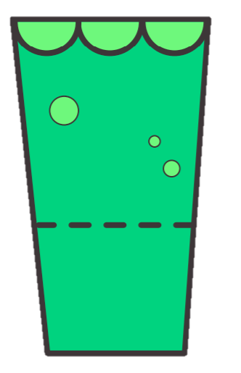

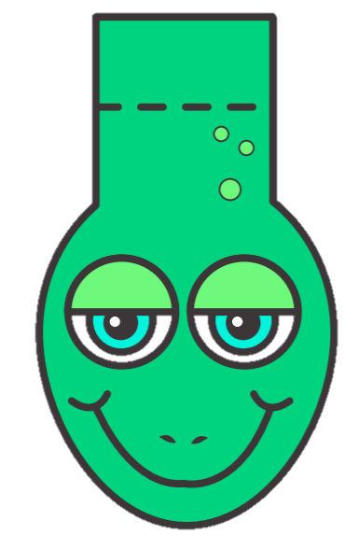

|  |  |  |
| --- | --- | --- |
| box of crayons clipart - Clip Art Library |  | Childrens Tricycle Transportation Cartoon Character Side View Vector  Illustration Stock Illustration - Download Image Now - iStock |
| Free School Apple Clipart | Free Images at Clker.com - vector clip art  online, royalty free & public domain |  | Beby Doll Clipart - Baby Doll Clipart Transparent PNG - 4918x5227 - Free  Download on NicePNG |
| Plastic Building Blocks. Toy Bricks Cart Graphic by smartstartstocker ·  Creative Fabrica |  | Toothbrush equipment tools vector illustration simple. dentist 3244082  Vector Art at Vecteezy |
| Bike  Take turns  Use a timer  One at a time |  | Crayons  One at a time  Each take a few  Trade |
| Babies  Each take one  One feed/one dress |  | Apple  Don’t share food  Adult cut it for each to have a piece |
| Toothbrush  Don’t share |  | Blocks  Each take some  Use a bucket  Use what you need  Work together  Make sure everyone has what they need |

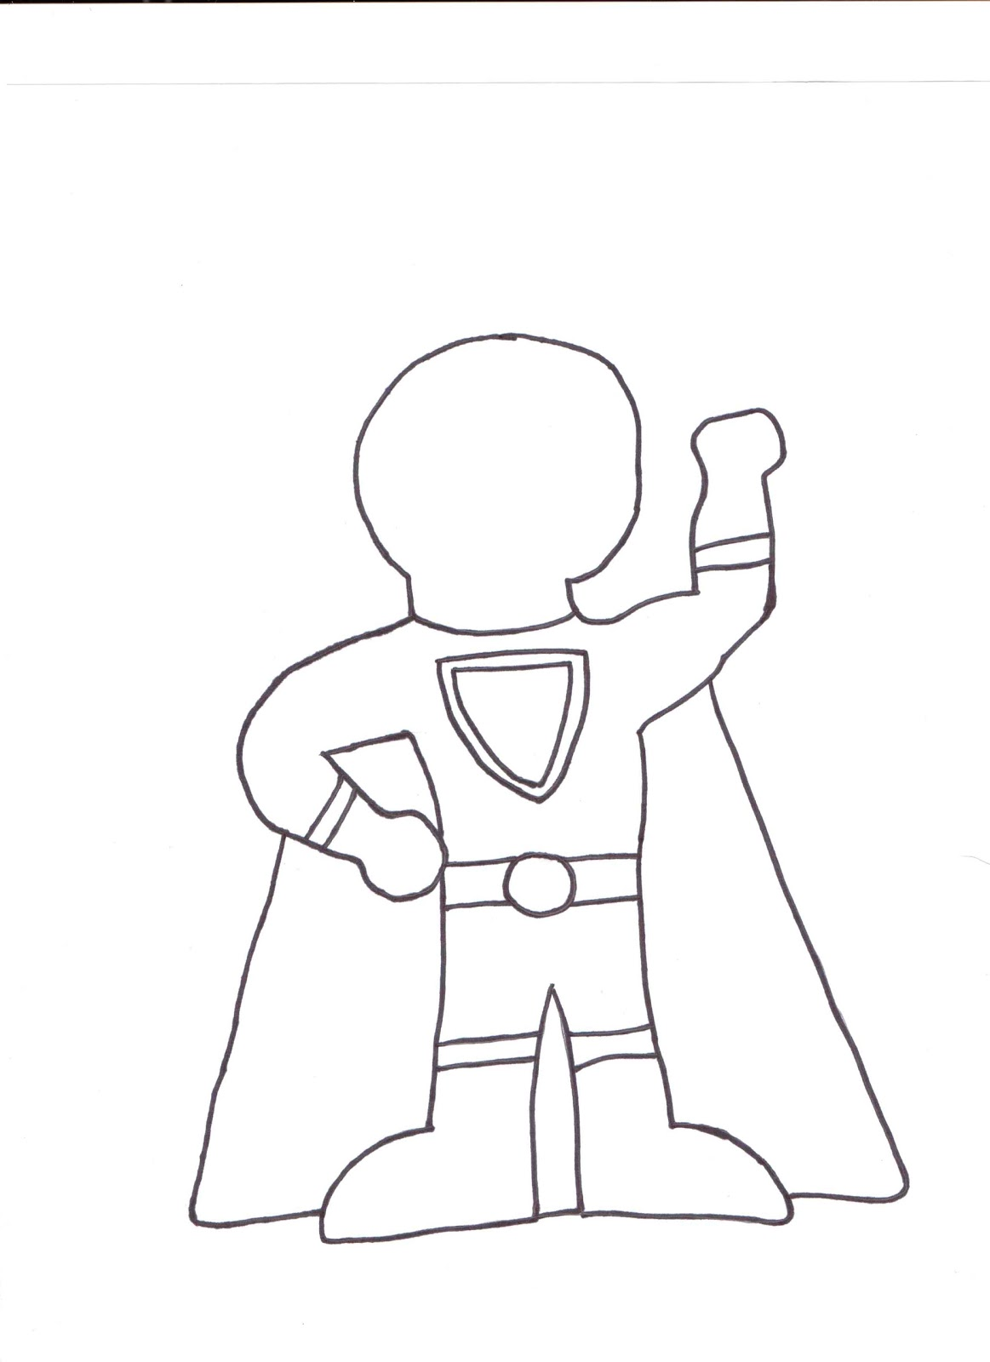

I can be a Super Friend when I

_____________________________________________!

Southern NH Services, Inc.-Child Development Program

Social Skill Lessons



My class will be completing social skill lessons on ____________________, with ________________________.

Day of the week teacher(s), other facilitator(s)

These lessons have been developed using Pyramid Model strategies to support children’s social emotional growth. Your child’s classroom will be introducing these skills and using them in the classroom.

You will receive lesson updates to support skills at home. Let us know if we can provide materials or additional support. Positive Solutions for Families is a parenting curriculum from Pyramid Model that supports families with promoting positive behavior at home.

|  |
| --- |
| Lesson 1 will cover Our 3 Rules and Feelings |
| Lesson 2 will cover Dealing with Feeling Mad and Tucker Turtle |
| Lesson 3 will cover Making mistakes |
| Lesson 4 will cover Problem Solving and Solutions |
| Session 5 will cover Sharing |
| Session 6 will cover Super Friend and Playing with others |
| 40,800+ Gratitude Illustrations, Royalty-Free Vector Graphics & Clip Art -  iStock | Thank you, Appreciation, Gratitude journalLesson 7 will cover Gratitude and Compliments |

Social Skill Session-1  
Feelings and Expectations

C:\Users\dvarney\AppData\Local\Microsoft\Windows\Temporary Internet Files\Content.IE5\BVB1T5FQ\MC900131253[1].wmf

Today we:

* Read *Feelings*
* Practiced introducing ourselves and naming our feelings
* Acted out many different feelings as a group
* We tried breathing 3 times to relax

Materials available:

* Rules poster
* Feelings and Thermometer poster

Next week we will focus on:

* Feeling mad
* Tucker Turtle Technique

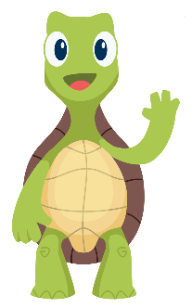

Materials available:

* Tucker book
* Tucker poster

Next week we will focus on:

* Making Mistakes

Today we:

* Read *Tucker Turtle Takes Time to Tuck and Think*
* We made our very own Tucker the Turtle who tucks in his shell
* Practiced Tucker’s 4 steps
  + Oh, No! Something bad happens!
  + Stop!
  + Take 3 deep breaths
  + Think of a solution

Social Skill Session-2  
Tucker the Turtle

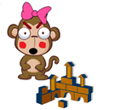

Social Skill Session-3   
Making Mistakes

Today we:

* Read *Minnie Made a Mistake*
* Shared something we are learning to do
* Played a tossing game
* We talked about practicing and trying when things are hard

Materials available:

* *Minnie Made a Mistake* book

Talk about:

* What you can do at home if you make a mistake

Next week we will focus on:

* Problem Solving and Solutions

Social Skill Session-4 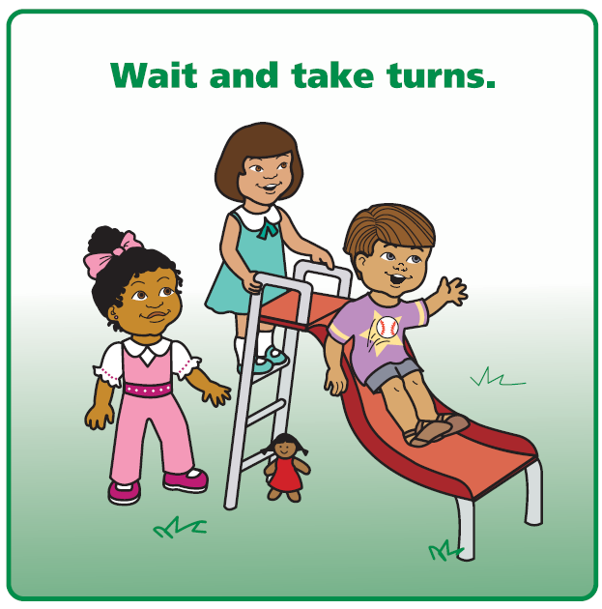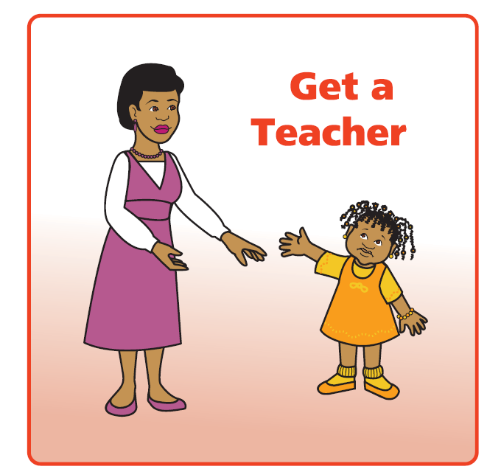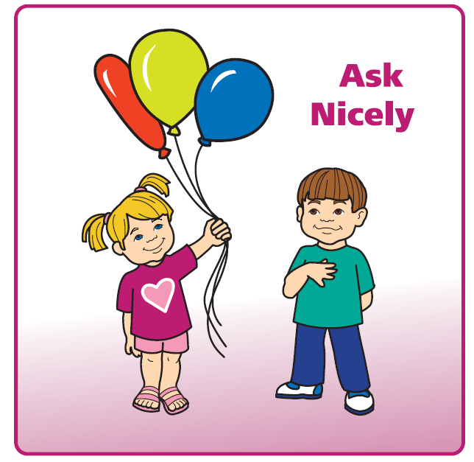  
Problem Solving and Solutions

Today we:

* Read *We Can Be Problem Solvers!*
* Talked about how bodies and faces show emotions
* Practiced problem solving steps
  + What is my problem
  + Think of Solutions
  + What will happen
  + Give it a Try!
* Learned about solutions

Materials available:

* Problem Solving poster
* Solutions poster

Next week we will focus on:

* Sharing

Social Skill Session-5

Sharing 

Today we:

* Read *The Ways We Share*
* Practiced asking to share
* Talked about what we can share
* Made art together ________________________

Materials available:

* The Ways We Share book

Talk about:

* How to share at home and taking turns

Next week we will focus on:

* Super Friend

Social Skill Session-6  
Super Friend



Today we:

* Read *I Can Be a Super Friend*
* Practiced asking to play too!
* Played ball as a group
* Talked about watching, waiting, and then joining play

Materials available:

* *I Can Be a Super Friend* book
* Super Friend Poster

Talk about:

* When you see me being a Super Friend

Next week we will focus on:

* Our last group

Social Skill Session-7

Thank you and

Congratulations



Today we:

* Read ____________________________
* Talked about the fun things we did in group
* Talked about what we are proud of and grateful for

Each child took home:

* Participation Certificate

Talk about:

* What I liked about group

**Keep working with me on all the skills I am learning!**



**Certificate of Completion**

presented to

For participating in the social skills lessons! Great Job!!!

___________________

Signature Date