SAFETY BASICS
All of SNHS Inc.’s Child Development program classrooms have the same 3 rules which are taught to all children entering the program. They are:
BE SAFE
BE KIND
BE CAREFUL WITH OUR THINGS
One very important part of teaching children to BE SAFE at school is pedestrian safety. This is helping children and their families stay safe while being dropped off and picked up from their Head Start classroom. Whether you walk, drive or bicycle to school, there are ways to make sure you and your child arrive safely.
This brochure explains our center safety rules and what your child will be learning about safety while in our program. If you have any questions or need help accessing safety equipment or information, please speak to your Family Worker. They will be glad to help you.

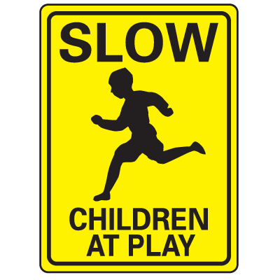
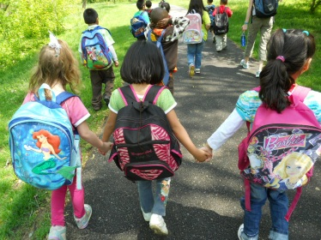
WALKING TO SCHOOL
Some of our children and families walk to school. Following these simple rules can help you and your child get there safely.
1. Always stay on the sidewalk. Walking in the street is not safe. If there is no sidewalk, walk on the left side of the road facing traffic as far off the road as possible.
2. Cross the street at the corner or crosswalk. Drivers cannot always see you come out from between parked cars.
3. Obey signals at corners and crosswalks. Never cross against the signal. Wait for the WALK sign. If a corner has a crossing guard, wait for their signal that is safe to cross
4. Stop at driveways. Look to see if a car is backing out. Trees, bushes and fences can stop the driver from seeing you.
5. Stop Look and Listen. These are 3 simple rules to remember to cross safely. Stop at the corner. Look both ways. Listen for the sound of cars or emergency vehicles coming. Then it is safe to cross.

DRIVING TO SCHOOL
Some of our families drive to school. Following these simple steps can help you get there safely.

- Always put you child in a child safety seat. This is the law in New Hampshire and the only way to insure your child is as safe as can be.
- Children always ride in the back seat. Whether in a safety seat or booster seat, children ride more safely in the back
- Always wear your seat belt. In the case of an accident, you need to be as safe as possible in order to help your child. It also sets a good example for your child.
- Follow all road signs and rules. Following the set speed limit and all other rules of the road will insure you get where you are going safely.
- Drive slowly and carefully in the school parking lot. The speed limit is 5 mph. There are children and families coming and going all day. Look out for little ones!

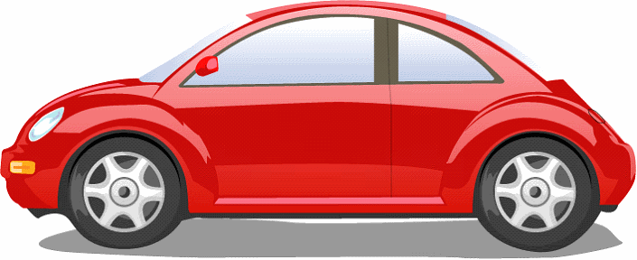
RIDING TO SCHOOL
Some of our families ride to school, either in strollers or on bicycles. Following these simple steps can help you get there safely.

- Use safety straps. Whether placing a child in a stroller or a bicycle seat, always buckle the safety straps to insure the child cannot stand up or fall out of the seat while moving.
- Wear helmets. Head injuries are the most serious injuries you can get from bike riding. Make sure that both you and your child are wearing helmets when biking, whether to school or around town.
- Follow all safety instructions. In order for safety equipment to work properly, all manufacturer’s instructions must be followed. Make sure that bike helmets are fitted to your child correctly, that all straps are fastened and that instructions on child size and weight are followed for all strollers.

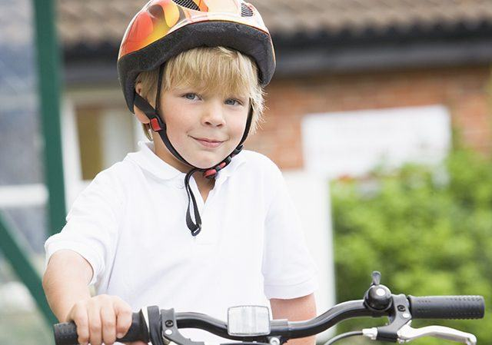
HEAD START SAFETY RULES
Keeping Head Start children and families safe is very important to us. We ask that anyone visiting our centers follow these simple steps when dropping off and picking up your child:
- Do not leave children alone in the car. Please bring all other children inside with you when you enter the building.
- Shut off your car while you pick up or drop off. This guards against theft as well as any accidents that may occur.
- Hold your child’s hand in the parking lot. There is a lot of traffic in and out of all our sites. Children do not always to look for danger and may get hurt.
- Hold your child’s hand all the way to and from the classroom door. Often, while parents are signing in or out or talking with staff, children will run ahead to the front door. As all our doors open easily from the inside, keeping them with you keeps them safe.
- Check in with the teacher. Drop off and pick up are busy times in the classroom. Make sure to tell a teacher that your child has arrives or is leaving so they can keep accurate count of the children for everyone’s safety.
SNHS Inc.
Child Development Program

Pedestrian/Auto
Safety

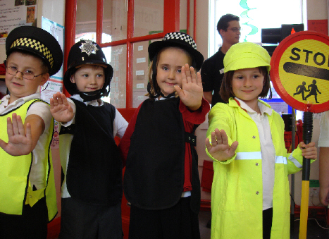

WELCOME
TO OUR
SAFE
SCHOOL

