Our Home Preschool Schedule
Breakfast
Story Time
Table Activity | 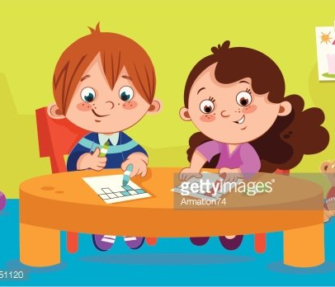
Outside/
Movement
Free Play | 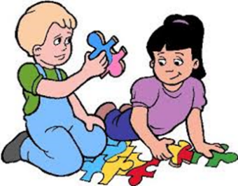
Clean up
Lunch
Music

This routine is to help you in providing some consistency between home and school.
Make it flexible to meet your family’s needs.
Remember to plan for the transitions between activities. Will your child help you or will they have a quiet activity to occupy them while you prepare, such as for lunch?

