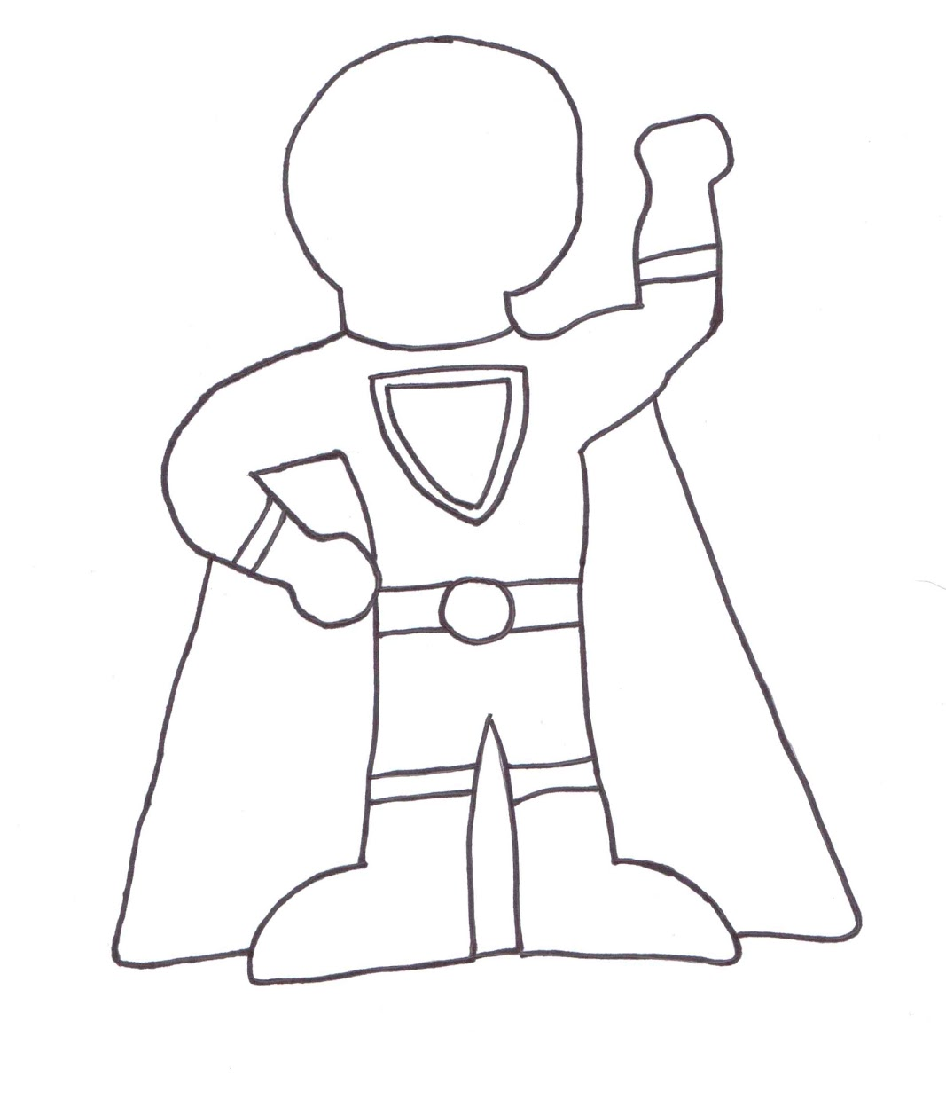

I can be a Super Friend when I

_________________________________________!

