Social Skill Session-1  
Getting to Know You

C:\Users\dvarney\AppData\Local\Microsoft\Windows\Temporary Internet Files\Content.IE5\BVB1T5FQ\MC900131253[1].wmf

Today we:

* Read *Feelings*
* Practiced introducing ourselves and naming our feelings
* Acted out many different feelings as a group
* We tried breathing 3 times to relax

Materials available:

* Rules poster
* Feelings and Thermometer poster

Next week we will focus on:

* Feeling mad
* Tucker Turtle Technique

j0137165[1]

Materials available:

* Tucker book
* Tucker poster

Next week we will focus on:

* Making Mistakes

Today we:

* Read *Tucker Turtle Takes Time to Tuck and Think*
* We made our very own Tucker the Turtle who tucks in his shell
* Practiced Tucker’s 4 steps
  + Oh, No! Something bad happens!
  + Stop!
  + Take 3 deep breaths
  + Think of a solution

Social Skill Session-2  
Tucker the Turtle

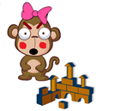

Social Skill Session-3   
Making Mistakes

Today we:

* Read *Minnie Made a Mistake*
* Shared something we are learning to do
* Played a tossing game
* We talked about practicing and trying when things are hard

Materials available:

* *Minnie Made a Mistake* book

Talk about:

* What you can do at home if you make a mistake

Next week we will focus on:

* Problem Solving and Solutions

Social Skill Session-4 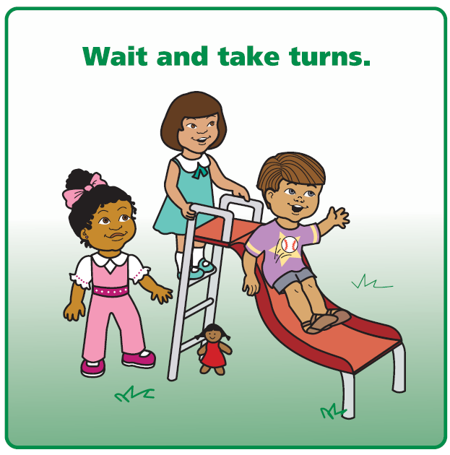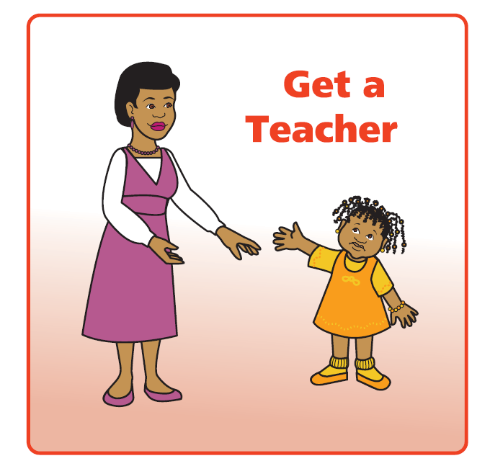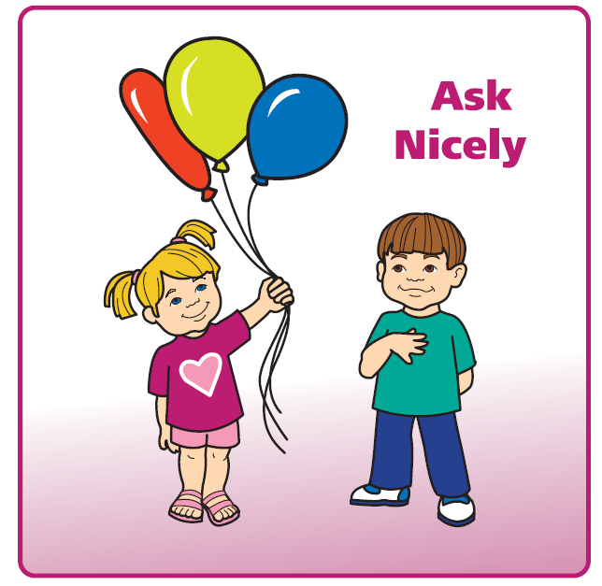  
Problem Solving and Solutions

Today we:

* Read *We Can Be Problem Solvers!*
* Talked about how bodies and faces show emotions
* Practiced problem solving steps
  + What is my problem
  + Think of Solutions
  + What will happen
  + Give it a Try!
* Learned about solutions

Materials available:

* Problem Solving poster
* Solutions poster

Next week we will focus on:

* Sharing

Social Skill Session-5

Sharing 

Today we:

* Read *The Ways We Share*
* Practiced asking to share
* Talked about what we can share
* Made art together ________________________

Materials available:

* The Ways We Share book

Talk about:

* How to share at home and taking turns

Next week we will focus on:

* Super Friend



Social Skill Session-6  
Super Friend

Today we:

* Read *I Can Be a Super Friend*
* Practiced asking to play too!
* Played ball as a group
* Talked about watching, waiting, and then joining play

Materials available:

* *I Can Be a Super Friend* book
* Super Friend Poster

Talk about:

* When you see me being a Super Friend

Next week we will focus on:

* Our last group

Social Skill Session-7

Thank you and

Congratulations

[](http://www.bing.com/images/search?q=certificate&view=detailv2&qft=+filterui:photo-clipart&id=C59D2A8471BD83692FC76B30084DD0650AD05AD5&selectedIndex=21&ccid=a2C8fgld&simid=608047544486134091&thid=JN.WIDDf4TbI4F6LO/YjsM6OQ)

Today we:

* Read ____________________________
* Talked about the fun things we did in group
* Talked about what we are proud of and grateful for

Each child took home:

* Participation Certificate

Talk about:

* What I liked about group

**Keep working with me on all the skills I am learning!**