C:\Users\dvarney\AppData\Local\Microsoft\Windows\Temporary Internet Files\Content.IE5\GMRVO47H\MC900436043[1].wmfSouthern NH Services, Inc.

Each group consists of about 6 children and 2 facilitators. They are held within the center. Children will be signed in and out of their classrooms. Program staff will support the groups as needed.

This group is provided by MSW Interns who are supervised by Dawn Varney, LICSW. They will be working on feelings, frustrations and playing with others. If you have any questions, please contact the center staff or Dawn Varney, LICSW at 668-8010 ext 6095.

Child Development Program

**Child’s Name**

**Is invited to**

**participate in the**

**Head Start**

**Social Skills Group**

j0137165[1]

Location

Time

Facilitators

Extending the Social Skill Lessons

**Children** **and Families** will receive:

* Books
* Posters
* Activities
* Group Updates

Materials and concepts are also used in classrooms.

Session 7 will cover:

Giving compliments

Review of Group

[](http://www.bing.com/images/search?q=certificate&view=detailv2&qft=+filterui:photo-clipart&id=C59D2A8471BD83692FC76B30084DD0650AD05AD5&selectedIndex=21&ccid=a2C8fgld&simid=608047544486134091&thid=JN.WIDDf4TbI4F6LO/YjsM6OQ)

Session 5 will cover:

Sharing

Working with others





Session 6 will cover:

Super Friend

Playing with others

Session 4 will cover:

Reading others emotions

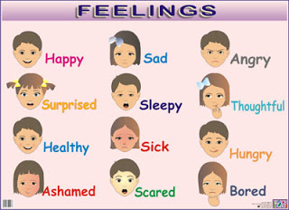

Session 3 will cover

Making mistakes

Problem Solving

Finding Solutions

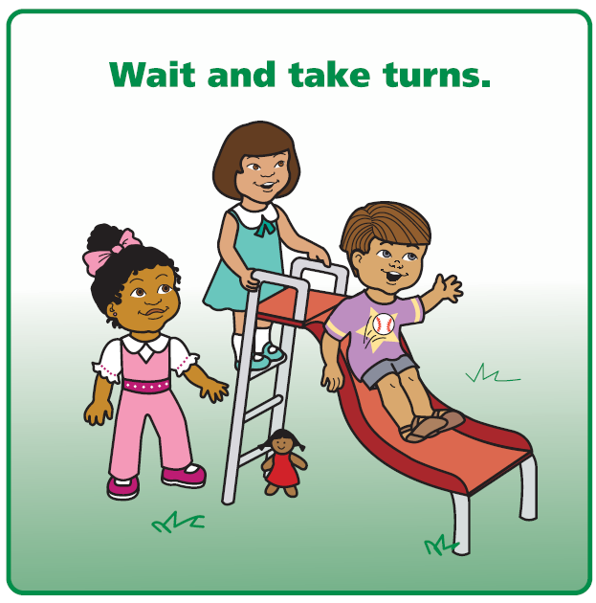

Session 2 will cover:

Dealing with Feeling Mad

Tucker Turtle



Session 1 will cover:

Our 3 Rules

Introduction to Feelings

