Join us in our Read Across America Celebration

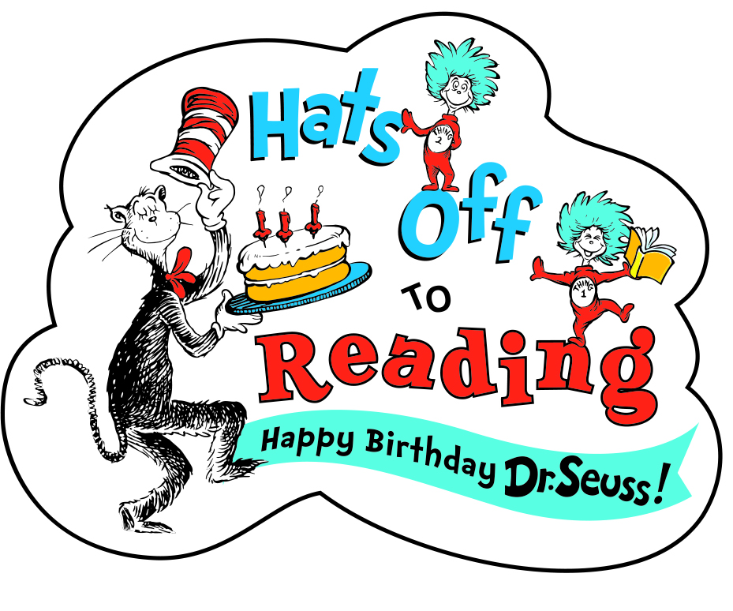
In celebration of Dr. Seuss’ birthday, we will celebrate Read across America. We will be focusing on the joy of reading in the classroom and encourage families to participate at home. Each classroom will set a goal for number of books read. We will provide a fun way to track the books you read. Please help us reach those goals!

The week of February 19th-23rd
We will celebrate with some fun Dr. Seuss activities at school as well provide some activities to do at home.
We hope you can join us on Friday February 23rd
For some Green Eggs and Ham.
*Please sign up with your Teachers

