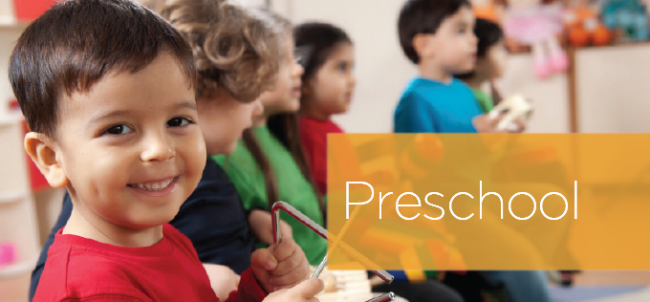

Part day preschool

Ages 3-5 years

School readiness activities

Nutritious meals

No cost to families

Individualized services for children with disabilities

Contact Us
Main Office
668-8010 x6098

WILL YOUR PRESCHOOLER BE READY?
Studies show children who receive early learning do better in school
NOW ENROLLING
Raymond Head Start
108 Fremont Road

Head Start Information  668-8010 x6098 or  1-800-322-1073  Espanol -1-800-322-1073 x6096 | Head Start Information  668-8010 x6098 or  1-800-322-1073  Espanol -1-800-322-1073 x6096 | Head Start Information  668-8010 x6098 or  1-800-322-1073  Espanol -1-800-322-1073 x6096 | Head Start Information  668-8010 x6098 or  1-800-322-1073  Espanol -1-800-322-1073 x6096 | Head Start Information  668-8010 x6098 or  1-800-322-1073  Espanol -1-800-322-1073 x6096 | Head Start Information  668-8010 x6098 or  1-800-322-1073  Espanol -1-800-322-1073 x6096 | Head Start Information  668-8010 x6098 or  1-800-322-1073  Espanol -1-800-322-1073 x6096

