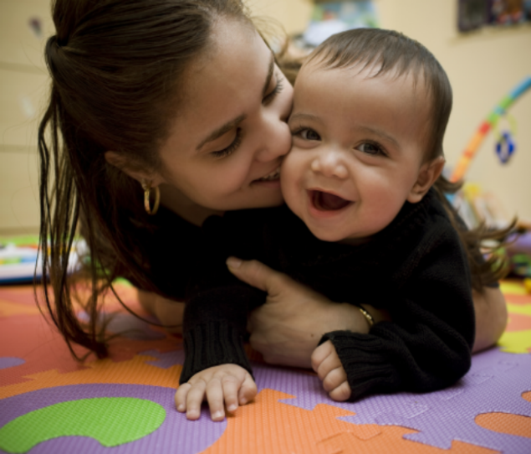
Guarderia de Dia Completo
Edades desde Nacimiento-3 años
Personal Educadores

Se dan Alimentos Nutritivos, pañales y fórmula

Programa de visitadoras en casa disponible gratis
Servicios Individualizados para niños con descapacidades
Contactarnos a la Oficina Principal668-8010 x6096

Es Early Head Start
Ideal Para Usted?

Haciendo diferencia en la vida de los niños y sus familias
MATRICULAS ABIERTAS
Manchester Early Head Start
160 Silver Street, Manchester, NH

Head Start Information  668-8010 x6096 or  1-800-322-1073  Español -1-800-322-1073 x6096 | Head Start Information  668-8010 x6096 or  1-800-322-1073  Español -1-800-322-1073 x6096 | Head Start Information  668-8010 x6096 or  1-800-322-1073  Español -1-800-322-1073 x6096 | Head Start Information  668-8010 x6096 or  1-800-322-1073  Español -1-800-322-1073 x6096 | Head Start Information  668-8010 x6096 or  1-800-322-1073  Español -1-800-322-1073 x6096 | Head Start Information  668-8010 x6096 or  1-800-322-1073  Español -1-800-322-1073 x6096 | Head Start Information  668-8010 x6096 or  1-800-322-1073  Español -1-800-322-1073 x6096

