WHO IS ELIGIBLE FOR HEAD START?

Head Start is a federally funded child development program for low income children and families. Children must be at least 3 years of age by September 30th and live in Hillsborough or Rockingham Counties. Families must meet income guidelines.

PROGRAM OPTIONS

Part Day Head Start: Classes meet for 3 ½ -4 hours, Monday through Friday, September through June. Participation is free of charge. Staff works with families in identifying transportation resources.

Head Start with Wrap-Around Child Care: This option is available for parents who are working, participating in job training or attending school full time. Participants in this option may work with the NH child care scholarship program to assist with child care costs. This option is available in Manchester, Nashua and Hillsboro only.

HOW DO I LEARN MORE?

For further information or to complete an application, contact the Head Start location nearest you. Part day centers can be reached during summer months at 668-8010 ext. 6098 or 1-800-322-1073 ext.6098. Applications are accepted year round.


This institution is an equal opportunity provider
Part Day Head Start Locations

Rockingham County:
Derry Head Start 216-8864

Raymond Head Start 244-2937

Portsmouth Head Start 422-8231

Hampton Head Start 601-2196

Seabrook Head Start 474-3507
Hillsborough County:
Greenville Head Start 878-4028

Hillsboro Head Start 464-3136

Manchester Locations:
40 Pine Street 668-8010

160 Silver Street 668-8010

Manchester Community 623-2332
College

435 S. Main Street 666-5982
177 Lake Ave 232-8864

Nashua Locations:
134 Allds Street 889-7812

Bronstein Apartments 882-3384

11th Street Apartments 882-6278

Head Start with Wrap Around Child Care:
Hillsboro 464-3136
Manchester 668-8010
Nashua 889-7812

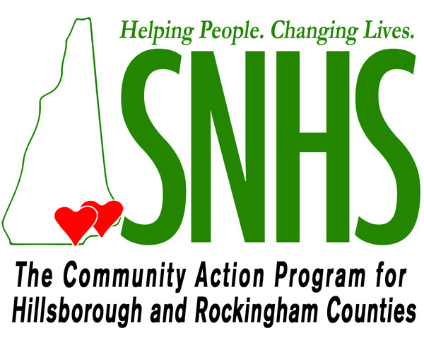

Southern New Hampshire Services, Inc.

HEAD START
Quality Pre-School Education for 3 and 4 yr. olds

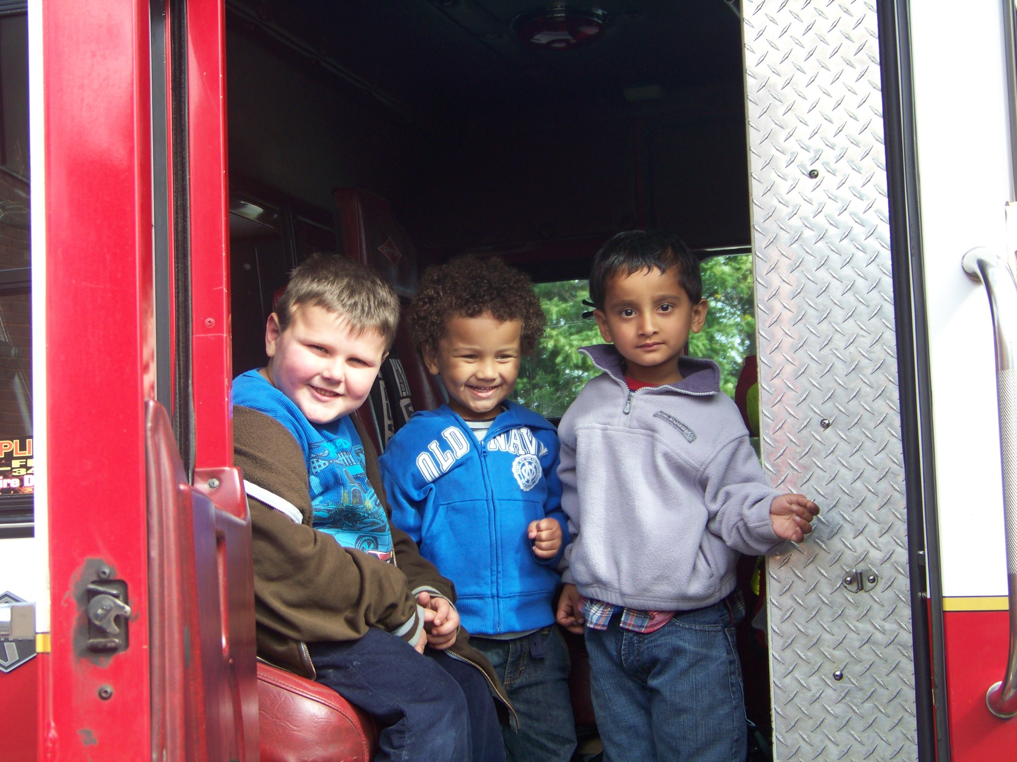

Head Start is a comprehensive preschool program for children and families which provides:

- Quality Preschool Education
- Services to Children with Disabilities
- Health & Nutrition Services
- Family Support Services
- Opportunities for Family Participation

EDUCATION

SNHS Inc. Head Start’s educational program is designed to meet each child’s individual needs. Goals are set for each child depending on their individual strengths and areas of growth. Every child receives a variety of learning experiences to foster intellectual, social and emotional development. Children are encouraged to express their feelings and to develop self-confidence and the ability to get along with others.

DISABILITY SERVICES

All children receive developmental screenings and ongoing assessments to help identify any areas of concern. Head Start staff work closely with community agencies and local school districts to coordinate services that meet the needs of children with disabilities and support the goals of any Individualized Education Plans (IEP).

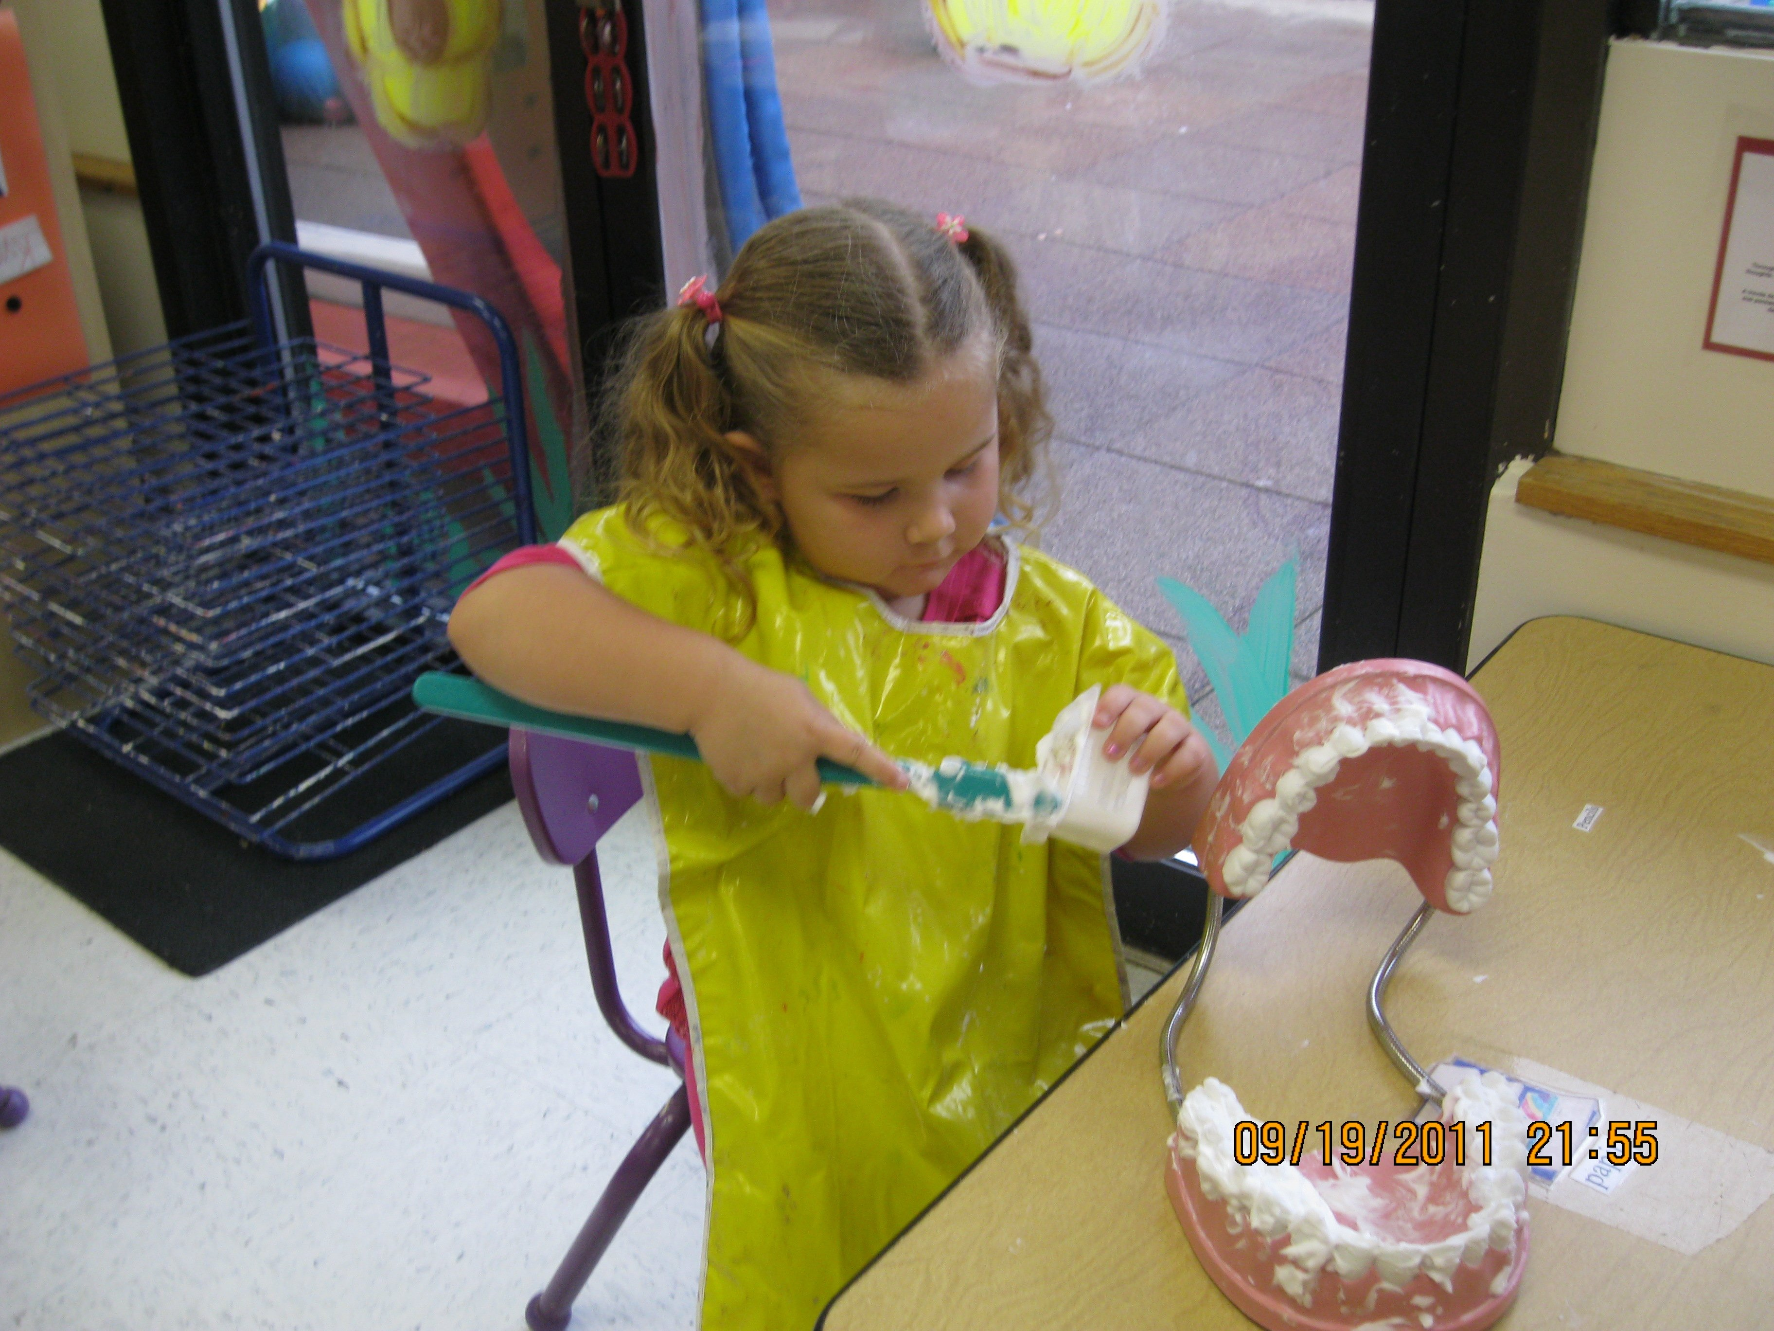

HEALTH & NUTRITION

Head Start emphasizes the importance of preventive health and works with families to address special health and nutritional needs. Children receive routine health screenings as well as nutritious family style meals based on USDA guidelines.
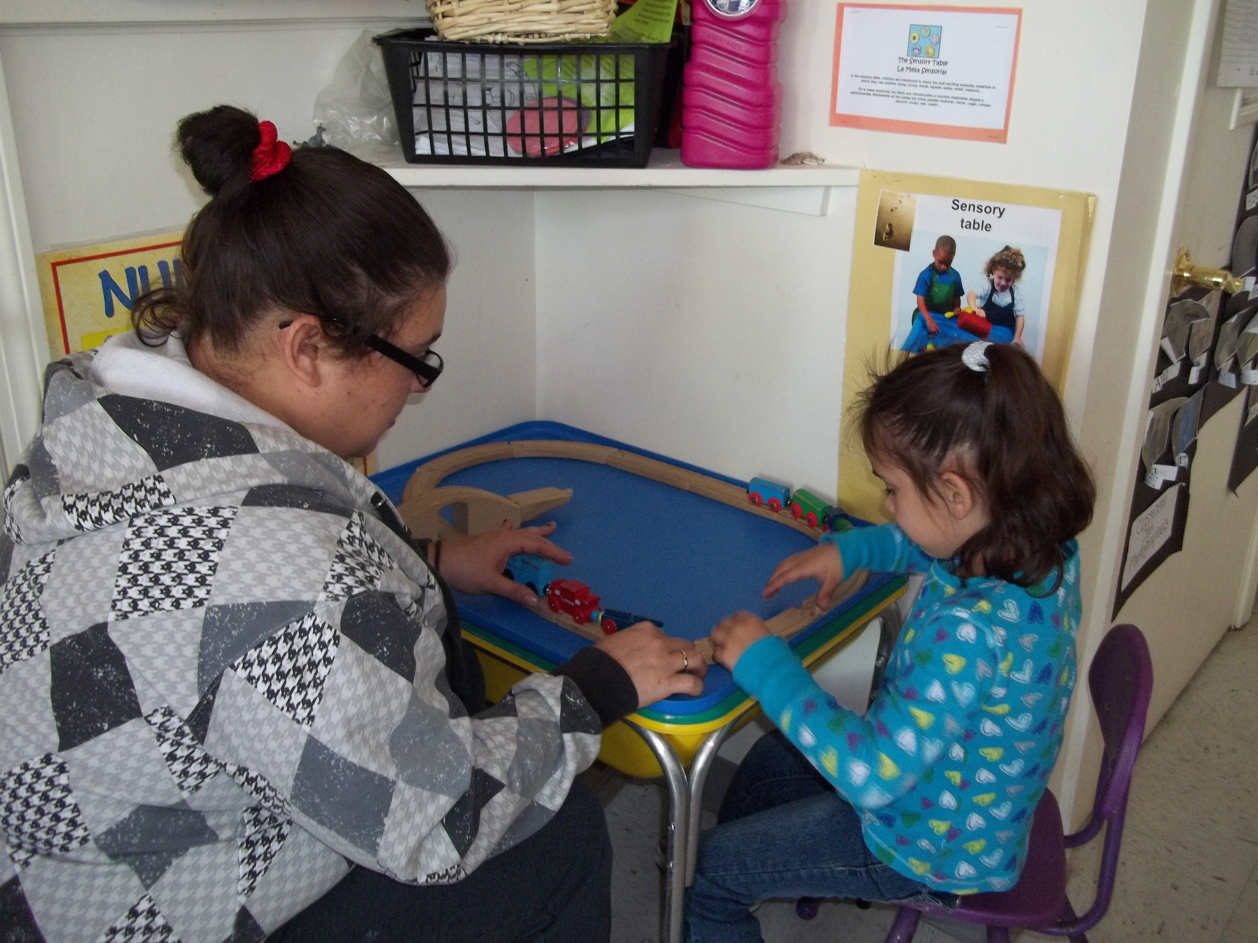

FAMILY ENGAGEMENT

Parents are the most important influence in their child’s development and are an integral part of the program. Head Start parents are encouraged:

- to take an active part in their child’s Head Start experience
- to be involved in the day-to-day activities of the center
- to meet with program staff quarterly to discuss child and family goals
- to participate in monthly center parent committee meetings
- to become involved in policy making and program planning through the Head Start Policy Council

SOCIAL SERVICES

Head Start offers parents opportunities and support for growth so they can identify their own strengths, needs and interests. Home and center visits by staff enable families to share information in an informal setting and to build relationships with parents that will support them in identifying and achieving family goals.

Family workers refer families to a variety of resources in the community, such as:

- Emergency food, housing, fuel, clothing and transportation assistance
- Financial planning/savings programs
- Adult and continuing education programs
- Job training/employment information
- Mental health care providers
- Human service agencies



