C:\Users\dvarney\AppData\Local\Microsoft\Windows\Temporary Internet Files\Content.IE5\BVB1T5FQ\MC900131253[1].wmf

Social Skill Group-1  
Getting to Know You

Today we:

* Read ____________________________
* Practiced introducing ourselves and naming our feelings
* Acted out many different feelings as a group
* We tried breathing 3 times to relax

Each child took home:

* Bumble Poster
* Rules poster
* Feelings and Thermometer poster

Next week we will focus on:

* Feeling mad
* Tucker Turtle Technique



For questions or concerns call Dawn Varney, LICSW at 668-8010 ext. 6095

j0137165[1]

Social Skill Group-2  
Tucker the Turtle

Today we:

* Read Tucker Turtle Takes Time to Tuck and Think
* We made our very own Tucker the Turtle who tucks in his shell
* Practiced Tucker’s 4 steps
  + Oh, No! Something bad happens!
  + Stop!
  + Take 3 deep breaths
  + Think of a solution

Each child took home:

* Tucker book
* Tucker poster
* And their Tucker Turtle

Next week we will focus on:

* Making Mistakes
* Solutions



For questions or concerns call Dawn Varney, LICSW at 668-8010 ext. 6095

Social Skill Group-3 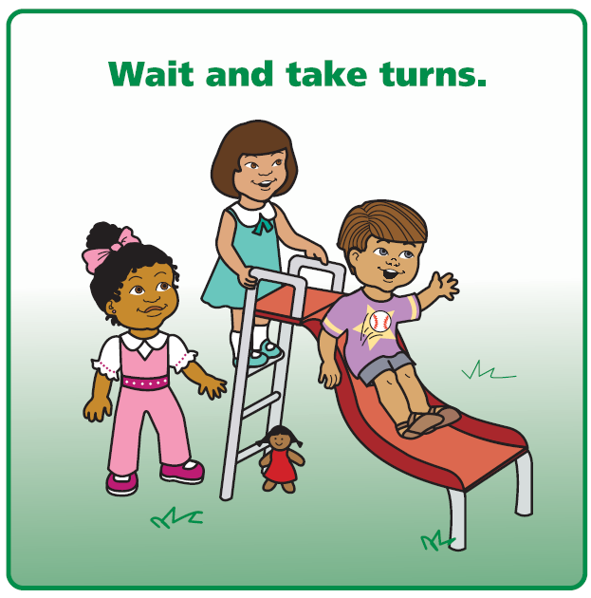  
Mistakes and Solutions

Today we:

* Read ____________________________
* Shared something we are learning to do
* Played a tossing game and talked about practicing
* Learned about the solution kit

Each child took home:

* Solution Kit

Talk about:

* What you can do at home if you make a mistake

Next week we will focus on:

* Other’s feelings



For questions or concerns call Dawn Varney, LICSW at 668-8010 ext. 6095

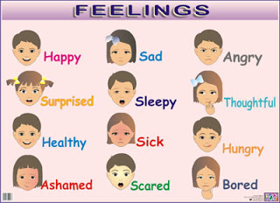

Social Skill Group-4  
Getting to Know Our Feelings

Today we:

* Read ____________________________
* Talked about how bodies and faces show emotions
* Played emotions charades
* Thought about what to do if a friend is sad or mad

Each child took home:

* Feeling Scenario cards
* Feeling word list

Next week we will focus on:

* Sharing



For questions or concerns call Dawn Varney, LICSW at 668-8010 ext. 6095

Social Skill Group-5

Sharing 

Today we:

* Read ____________________________
* Practiced asking to share
* Talked about what we can share
* Played Islands (like musical chairs)

Each child took home:

* The Ways We Share book

Talk about:

* How to share at home and taking turns

Next week we will focus on:

* Super Friend



For questions or concerns call Dawn Varney, LICSW at 668-8010 ext. 6095



Social Skill Group-6  
Super Friend

Today we:

* Read I Can Be a Super Friend
* Practiced asking to play too!
* Played ball as a group
* Talked about watching, waiting, and then joining play

Each child took home:

* I Can Be a Super Friend

Talk about:

* When you see me being a Super Friend

Next week we will focus on:

* Our last group



For questions or concerns call Dawn Varney, LICSW at 668-8010 ext. 6095

Social Skill Group-7

Congratulations

Today we:

* Read ____________________________
* Talked about the fun things we did in group
* Shared compliments with each other

Each child took home:

* Participation Certificate

Talk about:

* What I liked about group

Keep working with me on all the skills I am learning!

Thanks for letting me be part of our group!



For questions or concerns call Dawn Varney, LICSW at 668-8010 ext. 6095