FEELINGS

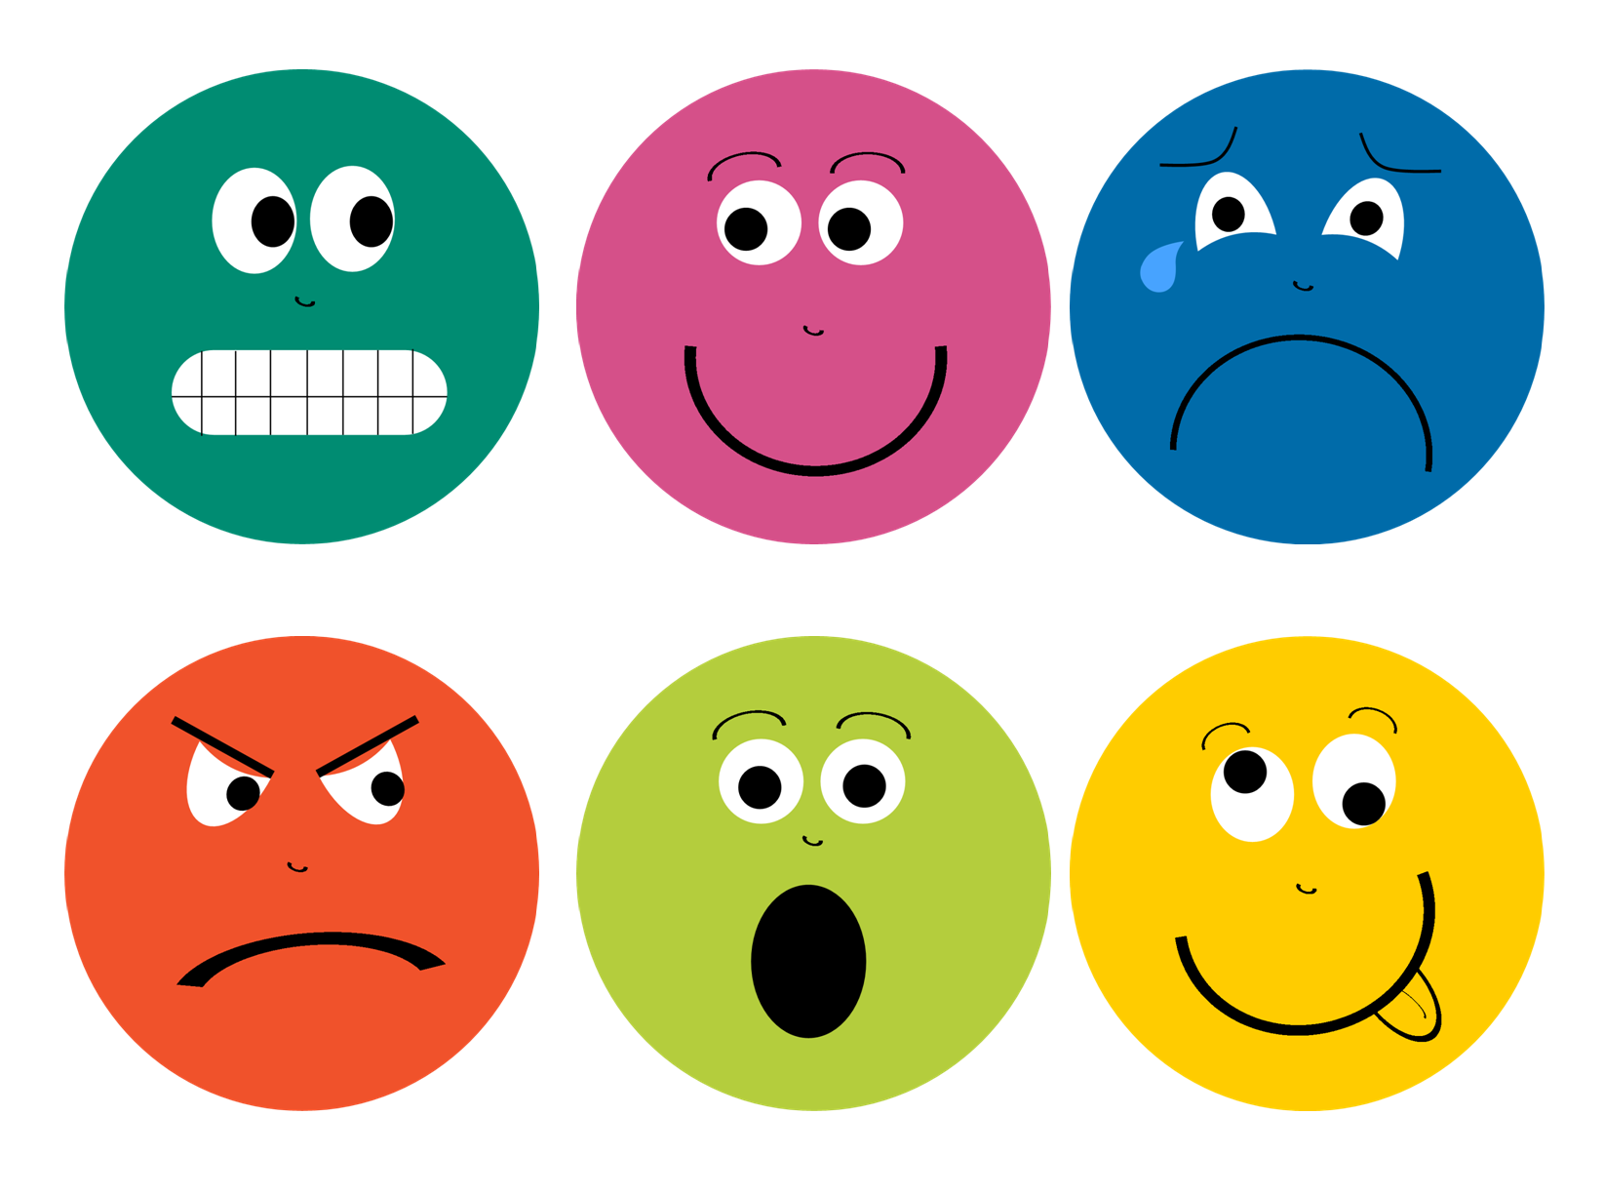

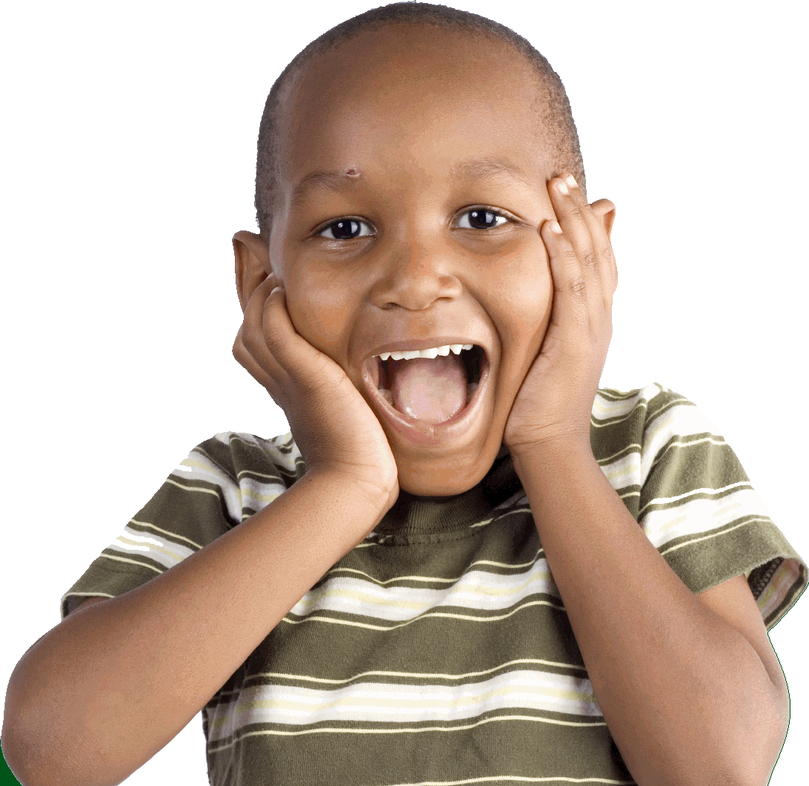

I feel excited when my friend Noah comes to visit.

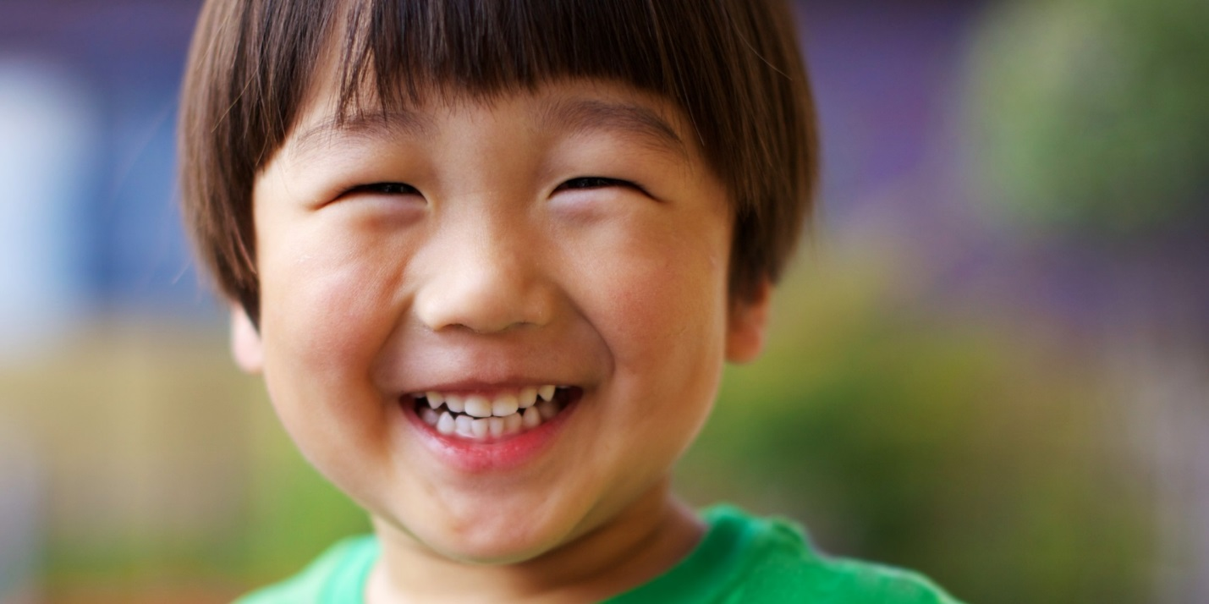

I feel happy when my friends share toys with me.

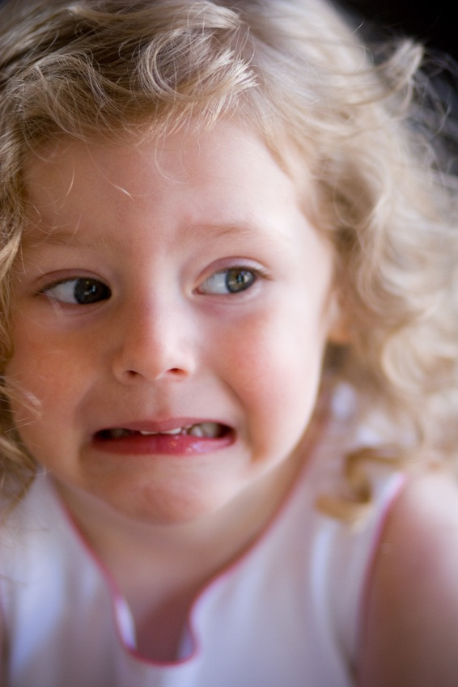

I am scared to go to bed in the dark.

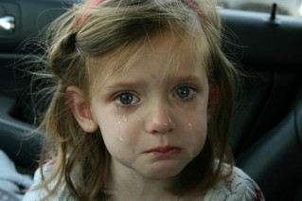

I feel sad when my friends don’t play or share with me.

I feel angry when my friend takes a toy from me.

I was surprised when my aunt brought me ice cream.

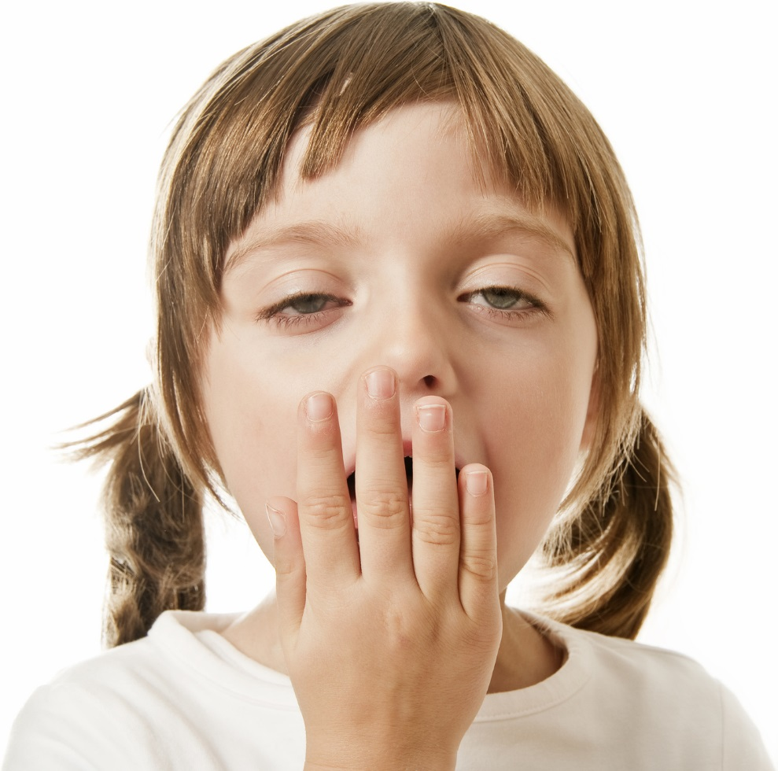

I played on the playground all day, I feel tired.

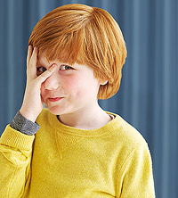

I felt embarrassed when I tripped in front of all my friends.

I felt nervous on my first day of school.

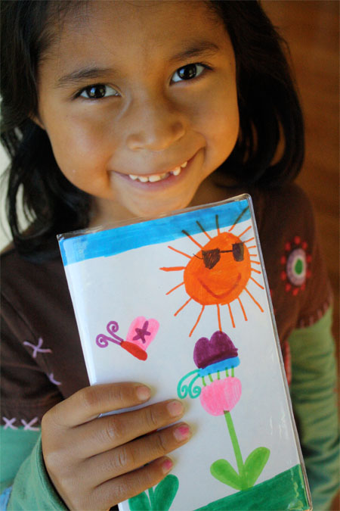

I felt proud when I tied my shoes all by myself.

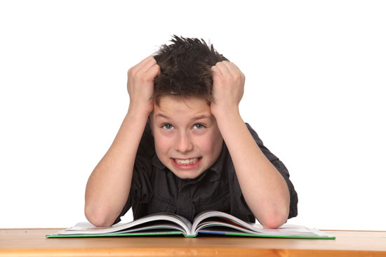

I feel frustrated when I don’t get to choose the book my teacher reads.

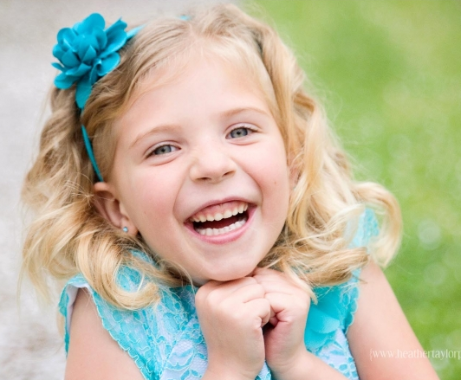

I feel loved when mommy kisses me on the cheek.

