**Art Center**

[](http://www.bing.com/images/search?q=art+materials+clip+art&view=detailv2&&id=AFF839A6B03A5492065A54931338D114C4C2E7D3&selectedIndex=41&ccid=o%2feDZ%2bqm&simid=608041394099325340&thid=JN.3CYXDKR3VEWUhbzw65p2pQ)

**Group**

[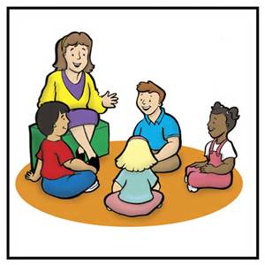](http://www.bing.com/images/search?q=circle+time+clip+art&view=detailv2&&id=F44B84FDE917C3F97A7F4CEFF4EC4F584BC7B1E5&selectedIndex=0&ccid=IvnEvjmt&simid=608022822661720890&thid=JN.nxhy9x0Ykb2myRSXKTvFSQ)

**Library**



**Blocks**

[](http://www.bing.com/images/search?q=Block+Area+Clip+Art&view=detailv2&&id=5D82311F4AA3E0CBA46E8639780627162FFFDEB4&selectedIndex=5&ccid=R7X1PcJg&simid=608047102113286044&thid=JN.6nnLFxdVXHVir31FVoGikA)

**Writing**

[](http://images.google.com/imgres?imgurl=http://school.discovery.com/clipart/images/writing-color.gif&imgrefurl=http://circe.wikispaces.com/The%2BClassroom&h=360&w=333&sz=14&hl=en&start=4&tbnid=XI1ciCxufQlQYM:&tbnh=121&tbnw=112&prev=/images%3Fq%3Dwriting%2Bcenter%2Bclipart%26gbv%3D2%26svnum%3D10%26hl%3Den)

**Music and**

**Movement**

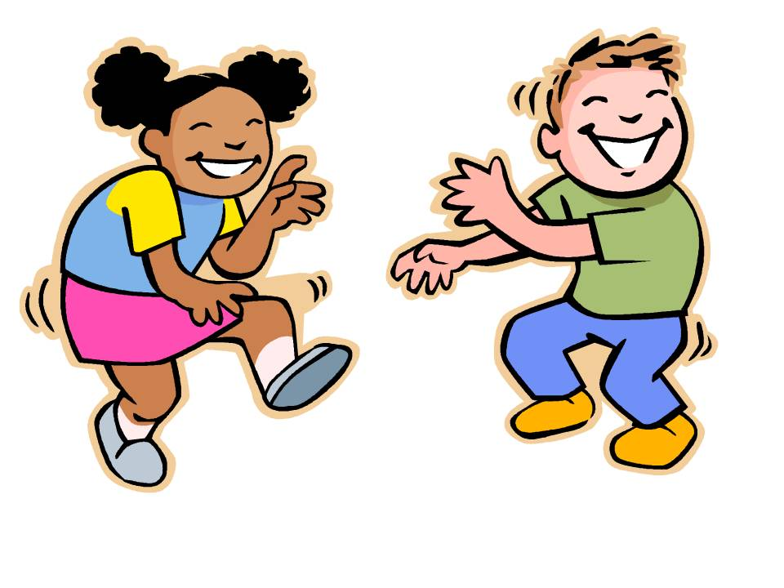

**Sand**

**Table**

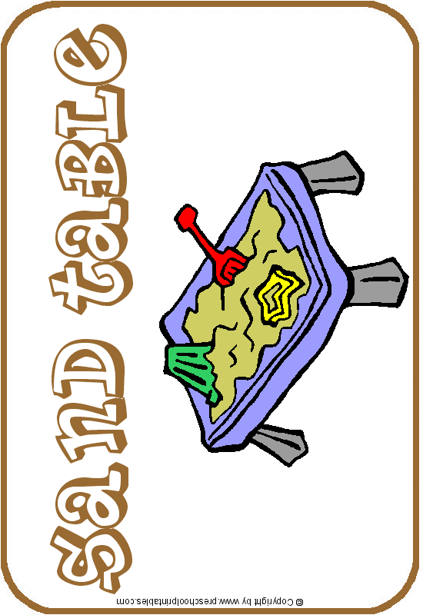

**Dramatic**

**Play**

[](http://www.mycutegraphics.com/graphics/school/school-kids/kitchen-center.html)

**Science**[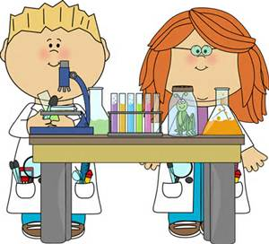](http://www.bing.com/images/search?q=Science+Clip+Art+School&view=detailv2&&id=251DCBC8DD5B15C186BCD580E905ABE322EB883D&selectedIndex=2&ccid=rbgo78NQ&simid=608003460953280244&thid=JN.0f60Ws7NTGiiQpFRAmzfBA)

**Puzzles**

[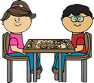](http://www.mycutegraphics.com/graphics/play/children-putting-puzzle-together-clip-art.html)

**Doll House**

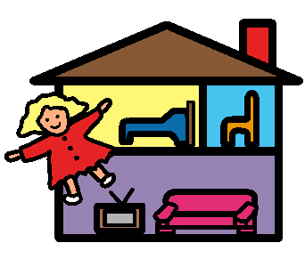

**Table**

**Activities**

[](http://www.mycutegraphics.com/graphics/school/school-kids/kids-playing-with-clay.html)

**Special**

**Activity**

[](http://images.google.com/imgres?imgurl=http://www.clipartheaven.com/clipart/education_%26_schools/cartoons/question_mark.gif&imgrefurl=http://clipartheaven.com/show/clipart/education_%26_schools/cartoons/question_mark-gif.html&usg=__PHit1GRKuW5Ld6YVo9zf2DTI4C8=&h=534&w=490&sz=12&hl=en&start=10&itbs=1&tbnid=8ET0Wi2vP-IXUM:&tbnh=132&tbnw=121&prev=/images%3Fq%3Dquestion%2Bmark%2Bclipart%26gbv%3D2%26hl%3Den)

**Listening**

**Center**

[](http://www.bing.com/images/search?q=child+headphones+clip+art&view=detailv2&&id=23F5AD327CAD688D8B838BE561D015FC4629236F&selectedIndex=28&ccid=G5JHyip5&simid=608015813266966882&thid=JN.l7I1h%2b4tB2rkl%2fXELNgnPQ)

**Easel**

