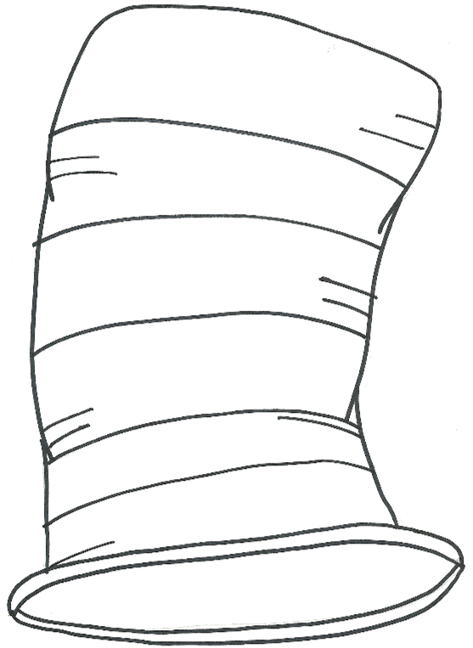

Author

Name of Book

Child’s Name

Child’s Name



Author

Name of Book

Author

Name of Book

Child’s Name

Author

Name of Book

Child’s Name